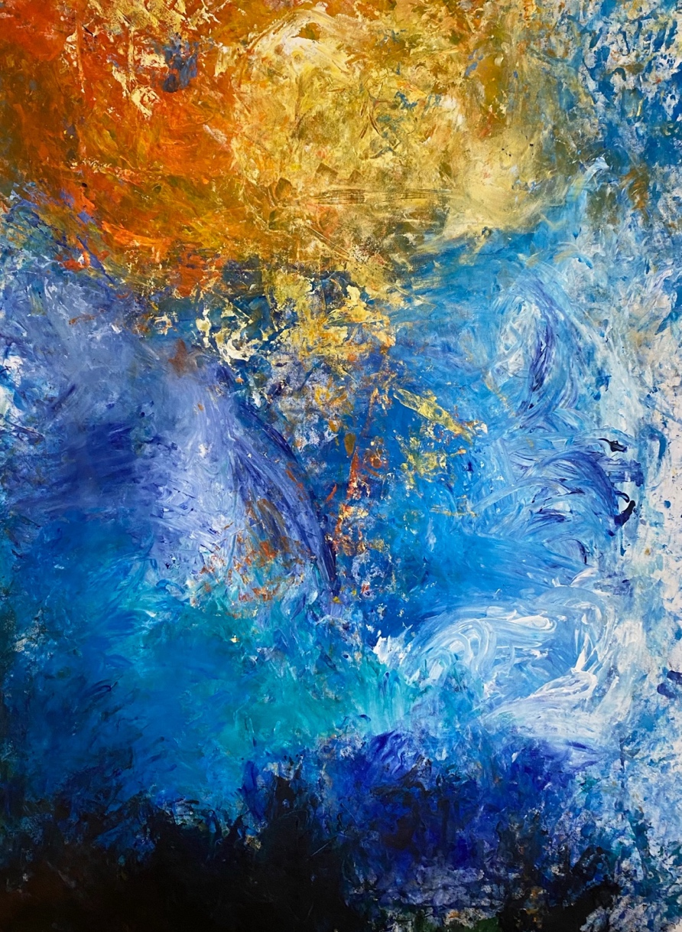

Undercover Artist Program 2025
Book 1 comedy and theatre

Hard words

This book has some hard words.

The first time we write a hard word
- the word is in blue
- we write what the hard word means.


You can get help with this book

You can get some one to help you

● read this book
● know what this book is about
● find more information.

About this book

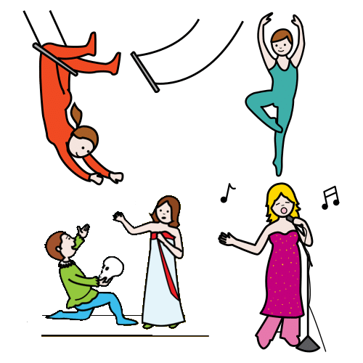
It is about Undercover Artist Festival.
It puts on shows like
- music
- dance
- circus
- comedy.

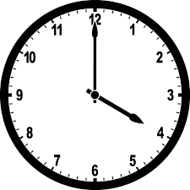
The book will tell you about a show
- when they are on
- where they are on
- what they are about.
There are 3 books
1 comedy and theatre
2 music
3 dance and circus

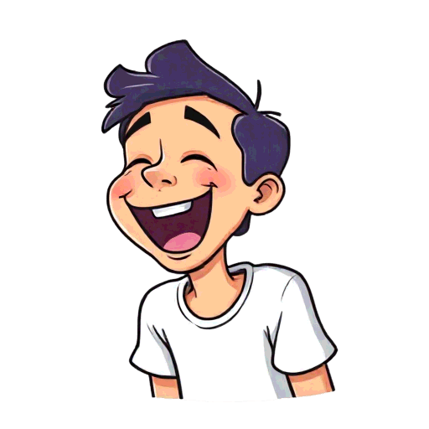
This is book 1.
It is about comedy and theatre.


We thank the First Nations people.

At the festival

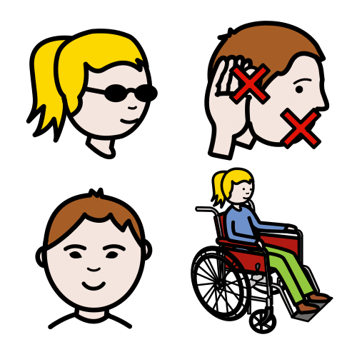

The main artist has a disability.

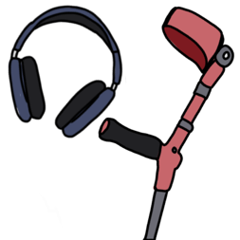

There will be access there.
It is what people with a disability need.
They will tell you in a book later.

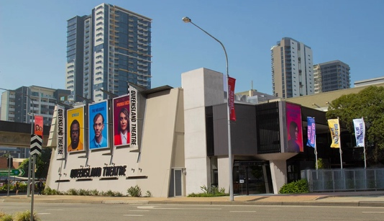
Each show will be at Queensland Theatre.

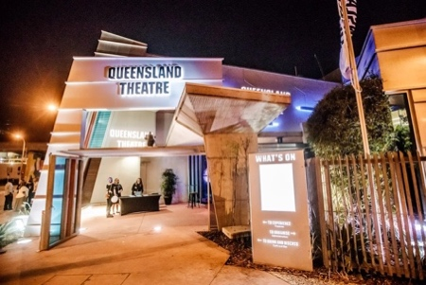
The address is 78 Montague Road.
It is in South Brisbane.

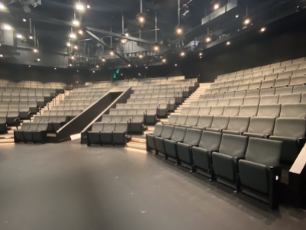
There are two theatres
- The Bille Brown Theatre
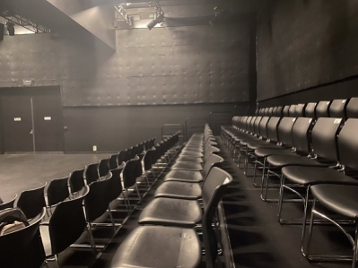
and
- Diane Cilento Studio.


There are content warnings.
These tell you if it can be hard.
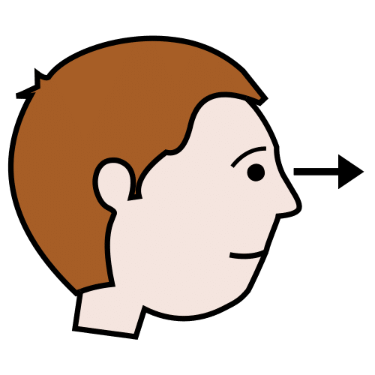
They can be hard to
- see
and
- hear.

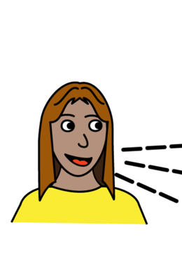
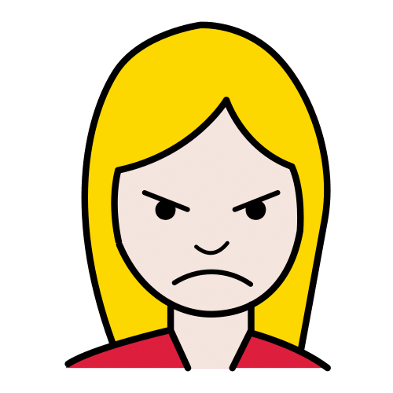
Like
- swear words


- drugs
- black out.

Comedy Club



It will go for an hour.



It will be on Tuesday 23 September.

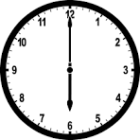
It will start at 6 pm.
It will finish at 7 pm.
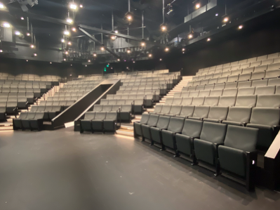
It will be in the Bille Brown theatre.
.


It is stand up comedy.
It is funny.

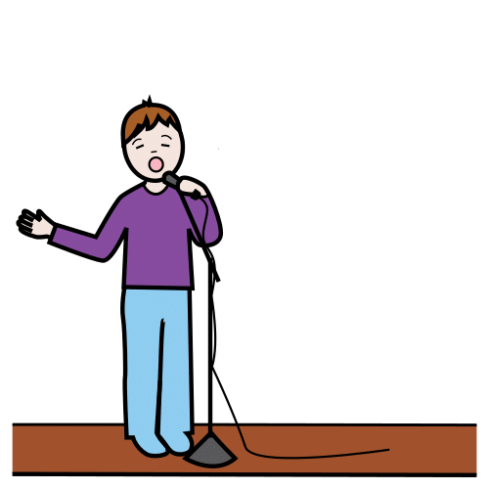
Comedians will perform.
They will tell a joke on stage.

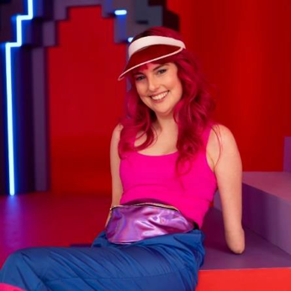
Madeleine will be the host.
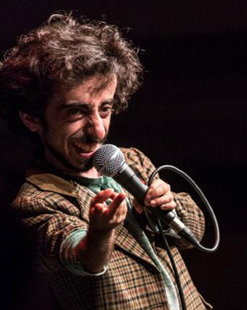
Imaan is the main one.

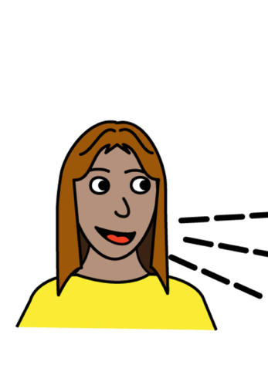
There are content warnings. Like
- swear words
- sex
- hate words

It will show hate for people with disability

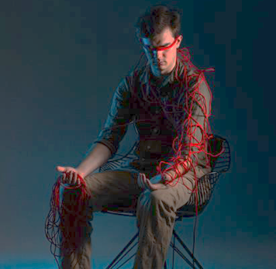
Day Dreamer

It will go for an hour.

It will be on Tuesday 23 September.

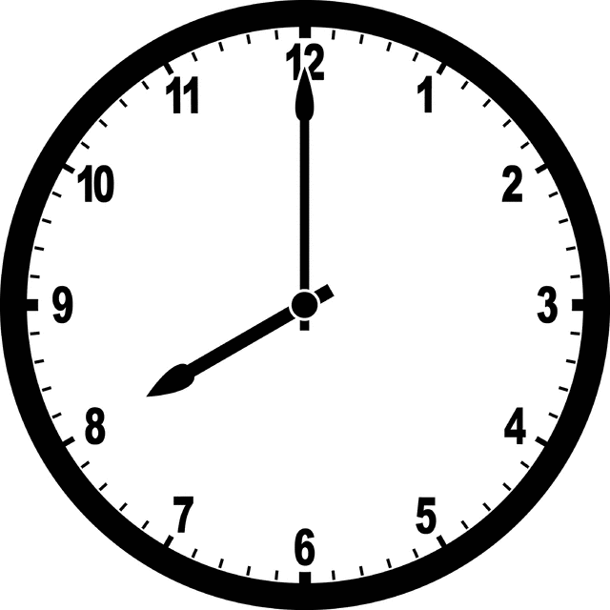
It will start at 8 pm.
It will finish at 9 pm.
It will be on Wednesday 24 September.

It will start at 4 pm.
It will finish at 5 pm.

It will be in the Diane Cilento Studio.
.


Day Dreamer is theatre.
There is poetry.
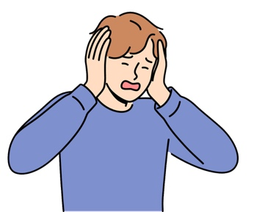
They have a disability.

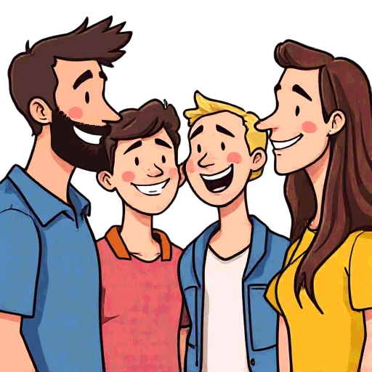
It looks at how to fit in.


They learn how to talk about disability.



There are content warnings. Like
- swear words
- death
- drugs
- bad parents.

It will show hate for people with disability.

It may be dark.

Comedy on Cue

It will go for an hour.

It will be on Friday 26 September.

It will start at 8 pm.
It will finish at 9 pm.
It will be in the Diane Cilento Studio.
.


It is improv.
People make up things on the spot.
They do not have a script.



It is done by Blah Blah Blah Improv.



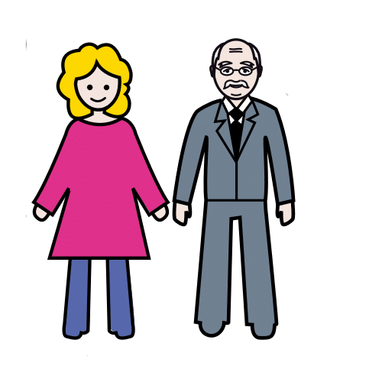
It is for every age.


There are games.
The people who watch can play.
They can give an idea.
Some will go on stage.


Something New

It will go for 2 hours.

It will be on Saturday 27 September.

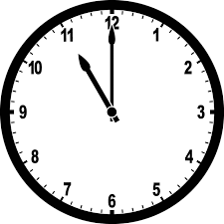
It will start at 11 am.
It will finish at 1 pm.

It will be in the Diane Cilento Studio.
.

There are 2 plays.
They will be read out loud.
I will listen.

The plays have not been on stage.

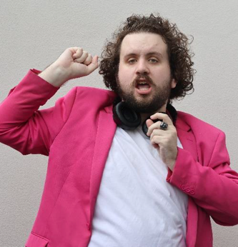
1 play is called Pretty Fucking Autistic.
It is by Oliver.


It is about Robert.
He has autism.


It is about Louise.
She is his mum.


His mum wants him to date.
She makes a date for him.


The date is with Hannah.
They have sex.

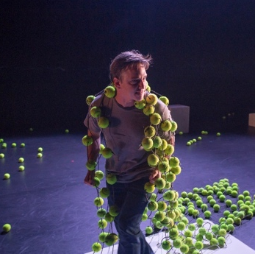
1 play is called Tracks.
It is by 2 people
- Alex
and
- Todd.

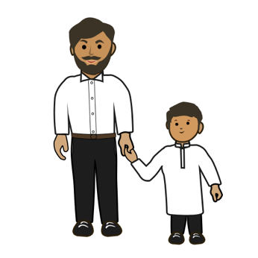
Todd is the dad.
Alex is his child.
The play is about them.


Alex is non-binary.
This is when you are not a
- man
or
- woman.

It has content warnings

- swear words
- sex.

You can talk to us



You can buy tickets.
You can call Queensland Theatre Box Office.
1800 355 528

or

You can go to the website.
www.undercoverartistfest.com


You can ask a question.
You can send an email.
undercoverartist@cpl.org.au

This is based on Undercover Artist
Festival 2025 festival program.

Alexandra Buchanan at Always Access wrote this Easy English document.
alex@alwaysaccess.com.au
June 2025

Images
Global Symbols
Vecteezy

