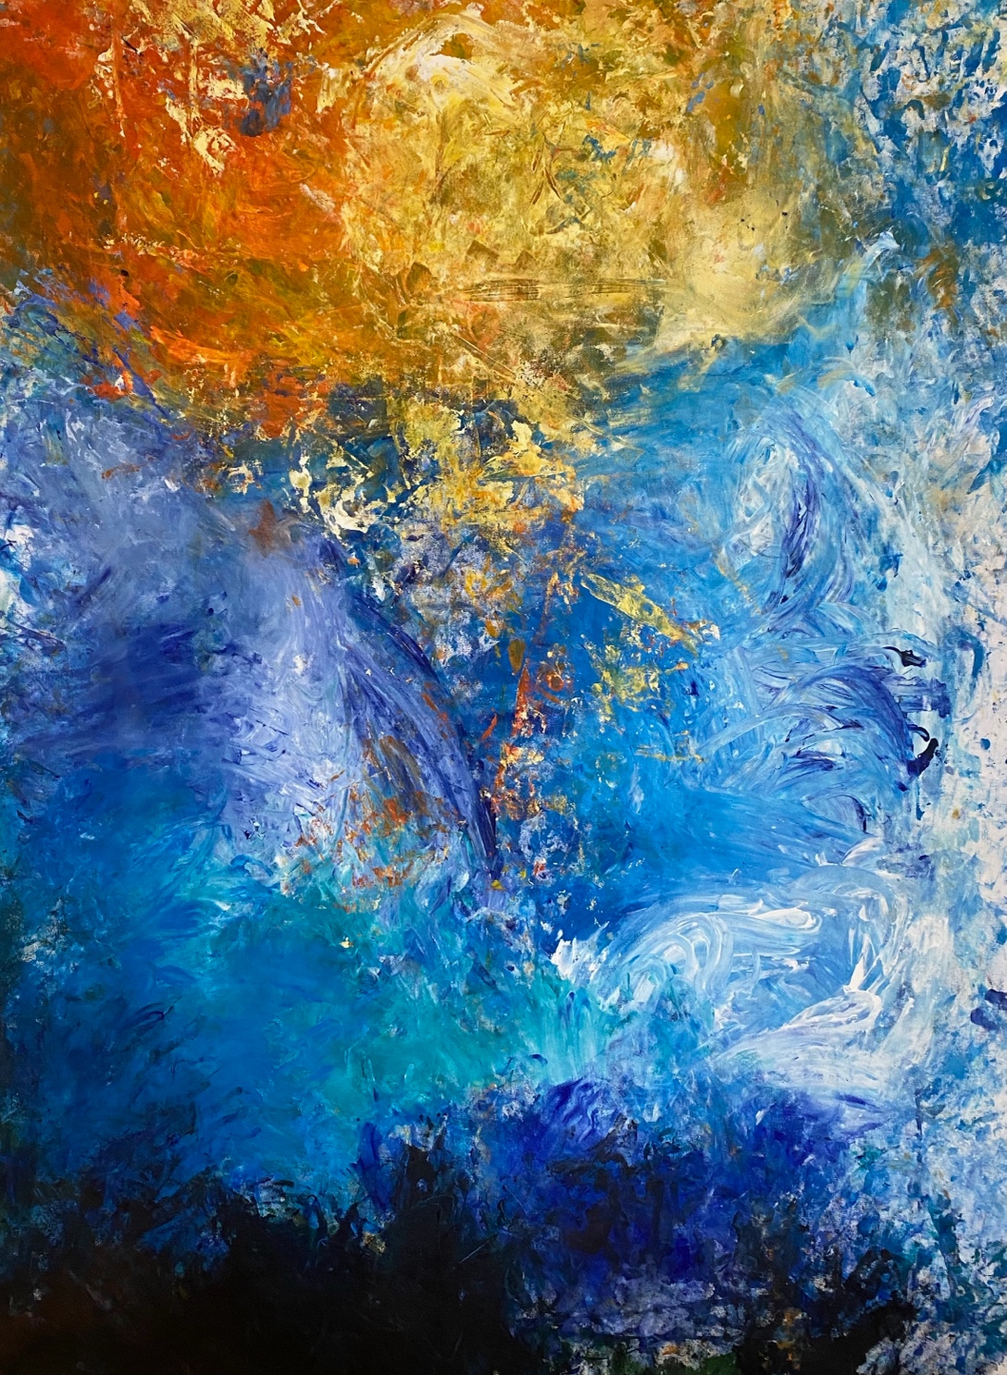

Undercover Artist Program 2025
Book 2 Music


Hard words

This book has some hard words.

The first time we write a hard word
- the word is in blue
- we write what the hard word means.


You can get help with this book

You can get some one to help you

● read this book
● know what this book is about
● find more information.

About this book

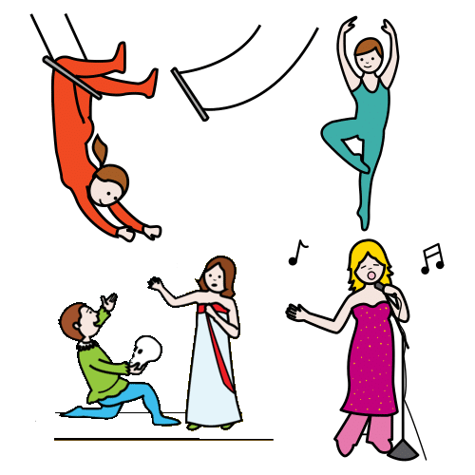
It is about Undercover Artist Festival.
It puts on shows like
- music
- dance
- circus
- comedy.

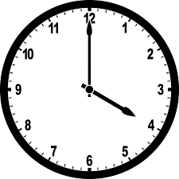
The book will tell you about a show
- when they are on
- where they are on
- what they are about.
There are 3 books
1 comedy and theatre
2 music
3 dance and circus

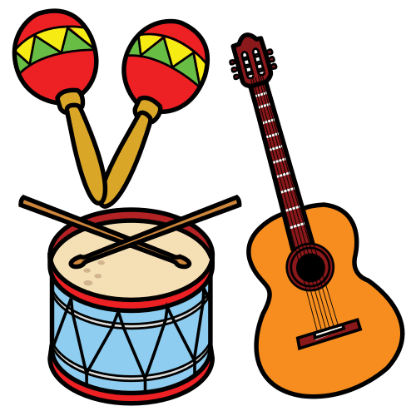
This is book 2.
It has the music shows.


We thank the First Nations people.

At the festival

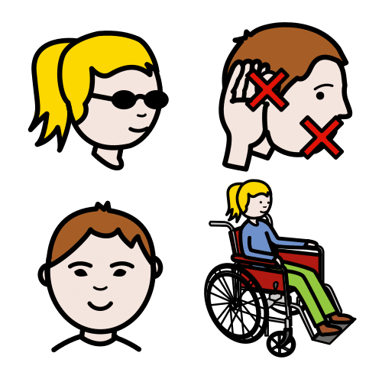

The main artist has a disability.

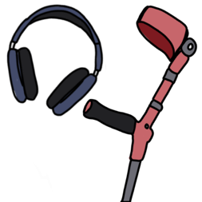

There will be access there.
It is what people with a disability need.
They will tell you in a book later.

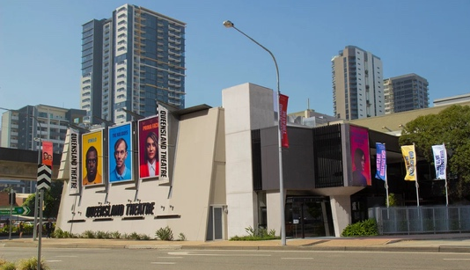
Each show will be at Queensland Theatre.

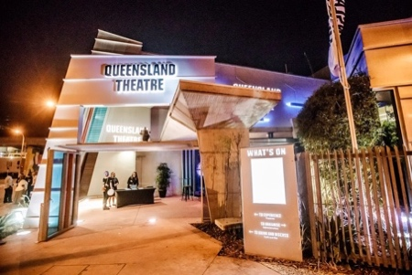
The address is 78 Montague Road.
It is in South Brisbane.

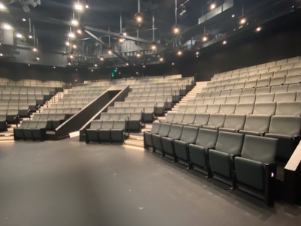
There are two theatres
- The Bille Brown Theatre
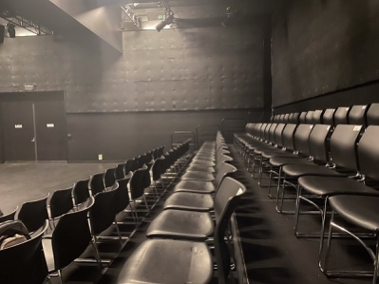
and
- Diane Cilento Studio.


There are content warnings.
These tell you if it can be hard.
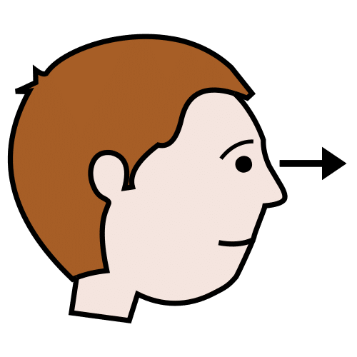
They can be hard to
- see
and
- hear.

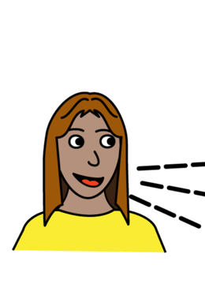
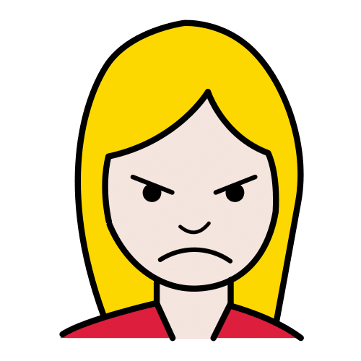
Like
- swear words


- drugs
- black out.

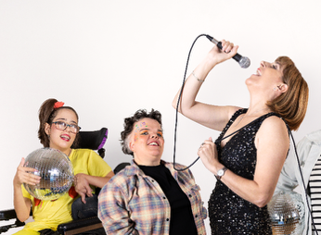
Icons Alive



It will go for an hour.



It will be on Saturday 20 September.

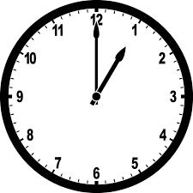
It will start at 1 pm.
It will finish at 2 pm.

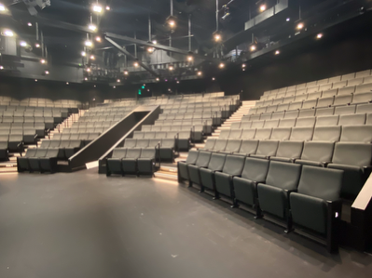
It will be in the Bille Brown Theatre.

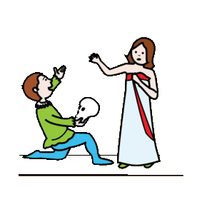
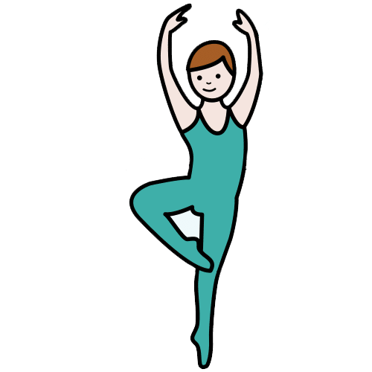
The show will have
- dance
- songs
- theatre.

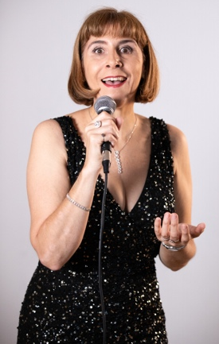
Karen will be the host.
She will tell you what will happen.


Many groups do it
- Screech Arts
- Madeline Stuart Dance Company
- Queensland Ballet
- Access Arts.



I will hear famous songs.

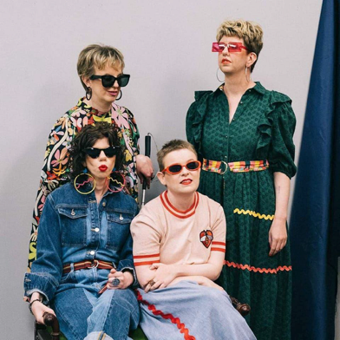
You ready for this?

It will go for an hour.

It will be on Saturday 20 September.

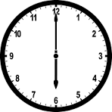
It will start at 6 pm.
It will finish at 7 pm.
It will be on Monday 22 September.

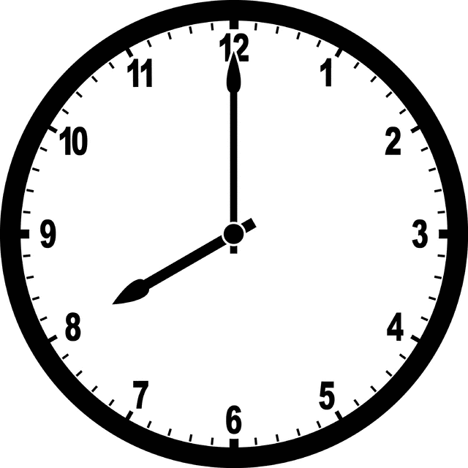
It will start at 8 pm.
It will finish at 9 pm.

It will be in the Diane Cilento Studio.
.

It is music.
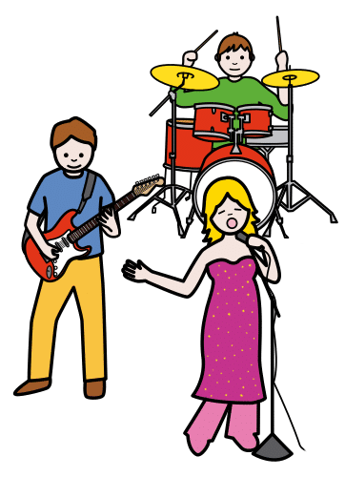
They write their own songs.
They have a live band.

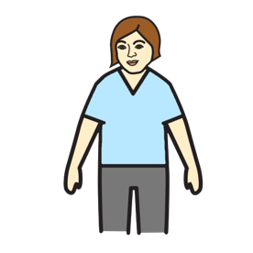
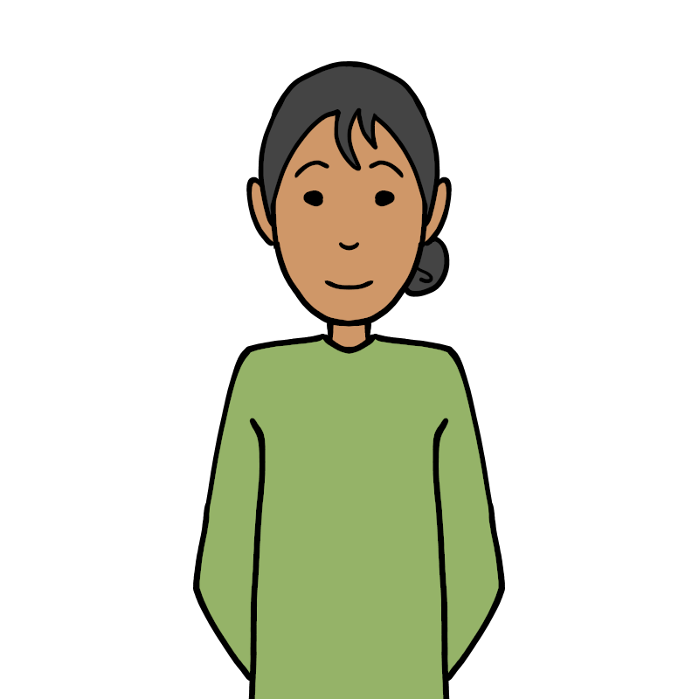
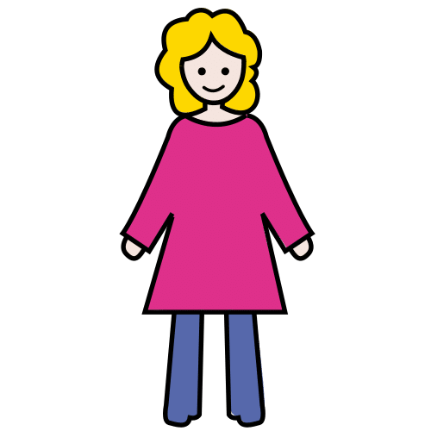
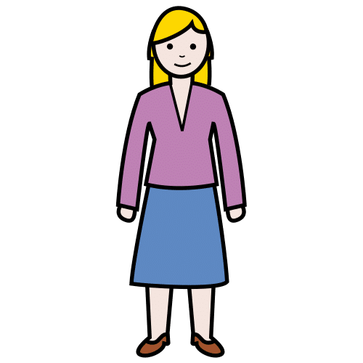
The Sisters of Invention do it.
It is 4 women.

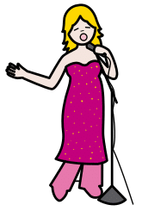

It is about being a pop star.


They did the show in Adelaide.
People said it was great.
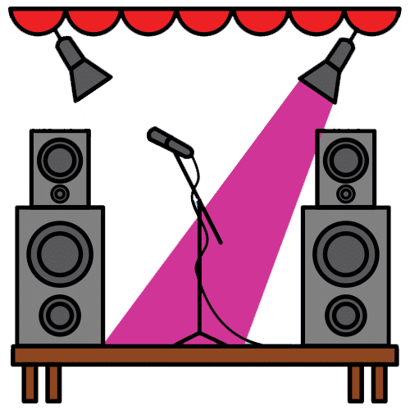
Wunder Sounds

It will go for 2 hours.

It will be on Saturday 27 September.

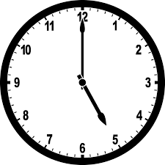
It will start at 5:30 pm.
It will finish at 7:30 pm.
It will be in the Bille Brown theatre.

It is music.


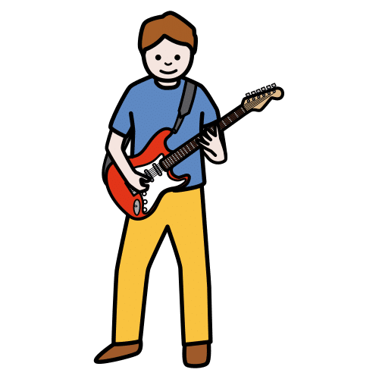
There will be 4 music shows.

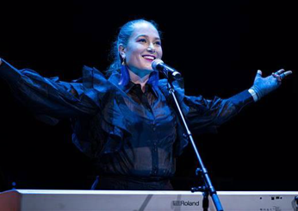
Emma Tomlinson sings pop
and wrote her music.

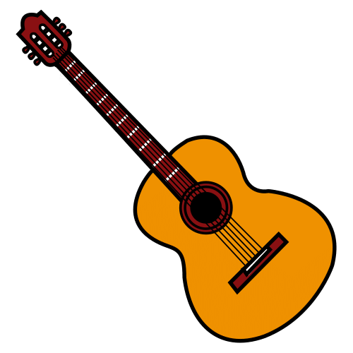
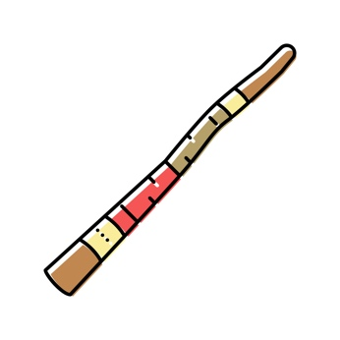
There is 3 people on stage.
They play the didgeridoo and guitar.

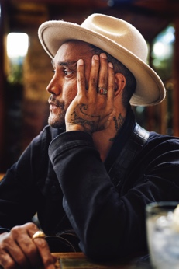
Jungaji is a First Nations man.
- He wrote his songs
and
- he will sing.

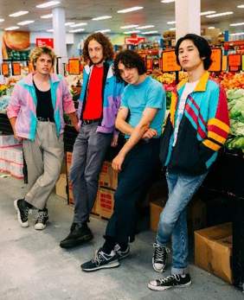
SAMMM is a band.
There are 4 people. The music is
- punk rock
and
- their words are true.

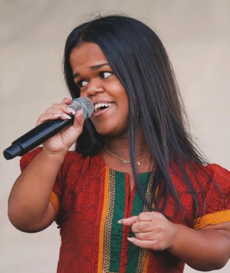
Nethra is a singer
and
she was on the Voice in 2024.

There are content warnings. Like
- swear words
- drugs.

Club Undercover

It will go for 2 hours.

It will be on Saturday 27 September.

It will start at 8 pm.
It will finish at 10 pm.

It will be in the Diane Cilento Studio.
.


It will be a silent disco.
People will dance to music.
The music will be in head phones.



There will be a DJ.


I can dance. I can
- stand
or
- sit down.


There will be
- colour lights
and
- no flashing lights.

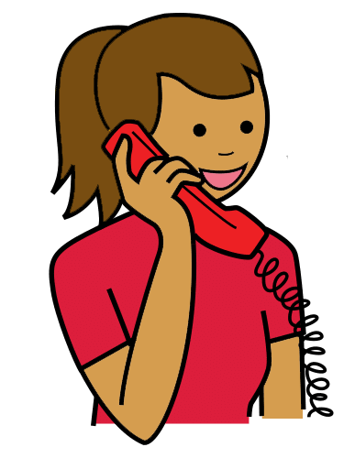
You can talk to us



You can buy tickets.
You can call Queensland Theatre Box Office.
1800 355 528

or

You can go to the website.
www.undercoverartistfest.com


You can ask a question.
You can send an email.
undercoverartist@cpl.org.au

This is based on Undercover Artist
Festival 2025 festival program.

Alexandra Buchanan at Always Access wrote this Easy English document.
alex@alwaysaccess.com.au
June 2025

Images
Global Symbols
Vecteezy

