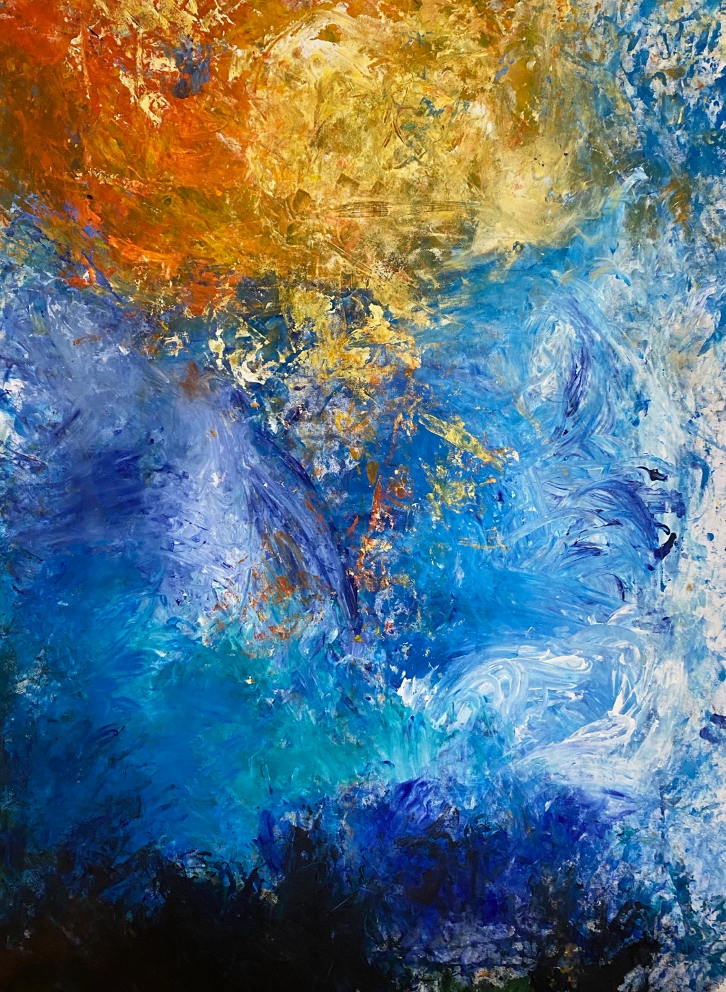

**Undercover Artist Program 2025**

**Book 3 dance and circus**

**

This book has some hard words.

The first time we write a hard word

* the word is in **blue**
* we write what the hard word means.

**

You can get some one to help you

● read this book

● know what this book is about

● find more information.

**

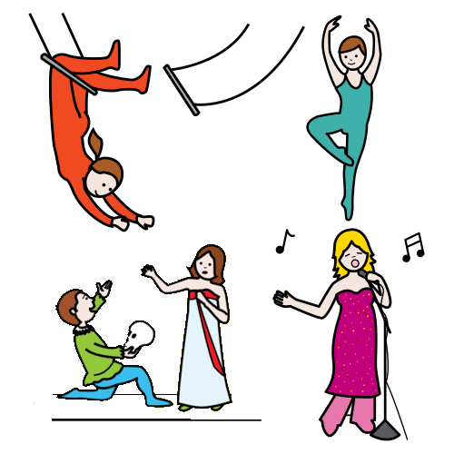It is about Undercover Artist Festival.

It puts on shows like

* music
* dance
* circus
* comedy.

The book will tell you about a show

* when they are on
* where they are on
* what they are about.

There are 3 books

1 comedy **and** theatre

2 music

3 dance **and** circus

This is book 3.

It is about dance and circus.

We thank the First Nations people.

**At the festival**

The main artist has a disability.

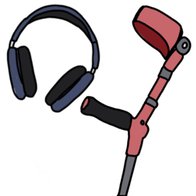

There will be **access** there.

It is what people with a disability need.

They will tell you in a book later.

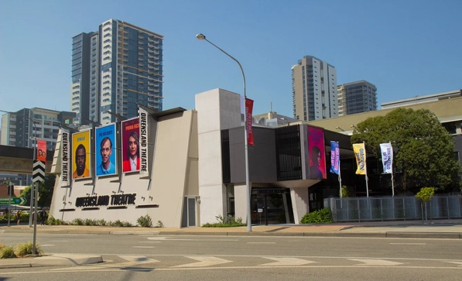Each show will be at Queensland Theatre.

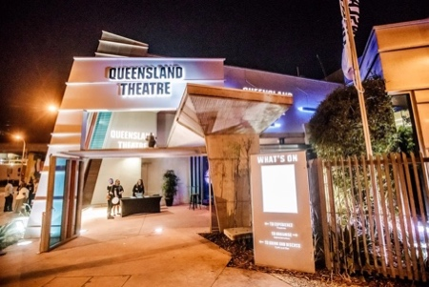The address is 78 Montague Road.

It is in South Brisbane.

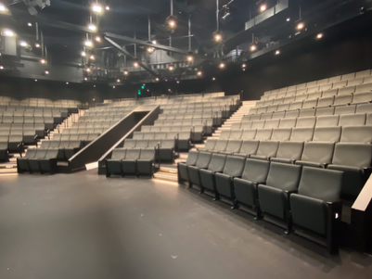There are two theatres

* The Bille Brown Theatre

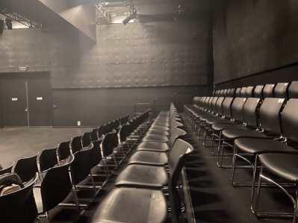**and**

* Diane Cilento Studio.

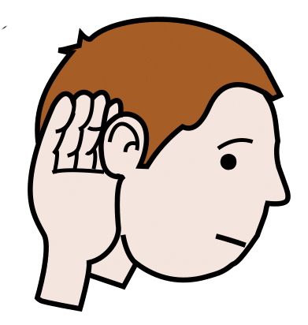There are **content warnings**.

These tell you if it can be hard.

They can be hard to

* see

**and**

* hear.

Like

* swear words
* A syringe with a red cap

  AI-generated content may be incorrect.A group of pills and tablets

  AI-generated content may be incorrect.drugs
* black out.

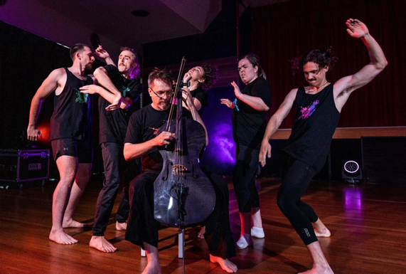**Wired Differently**

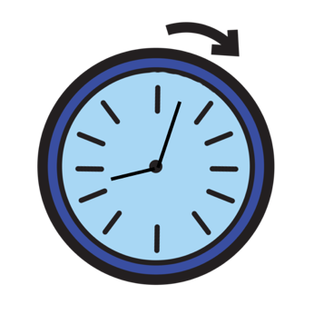

It will go for an hour.

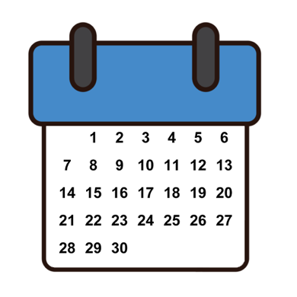

It will be on Monday 22 September.

It will start at 6 pm.

It will finish at 7 pm.

It will be on Wednesday 24 September.



It will start at 6 pm.

It will finish at 7 pm.

It will be on Friday 26 September.

It will start at 6 pm.

It will finish at 7 pm.

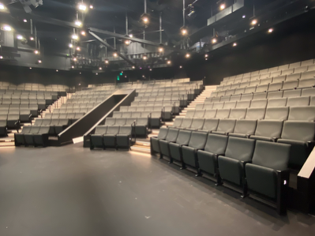

It will be in the Bille Brown theatre.

.

It’s **physical theatre**.

They use their body to tell the story.

It is done by groups

* Screech Arts

**and**

* Zen Zen Zo.

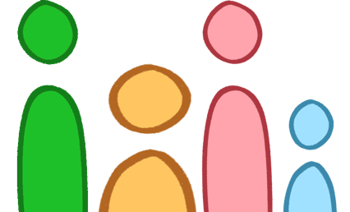They love that we are different.

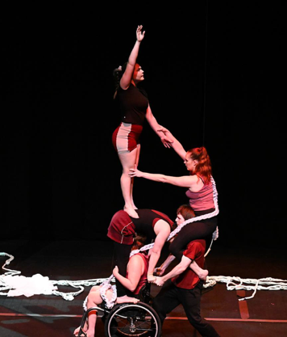

**6 Degrees**

It will go for an hour.

It will be on Tuesday 23 September.



It will start at 4 pm.

It will finish at 5 pm.

It will be on Wednesday 24 September.



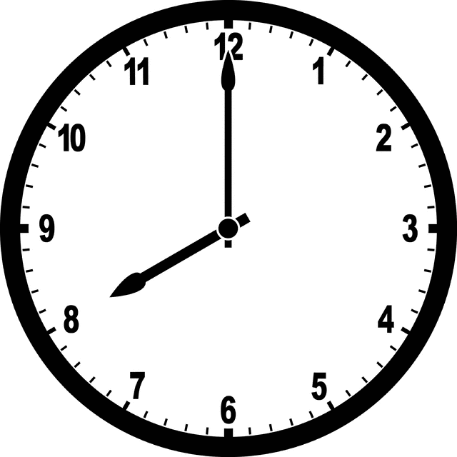It will start at 8 pm.

It will finish at 9 pm.

It will be in the Diane Cilento Studio.

.

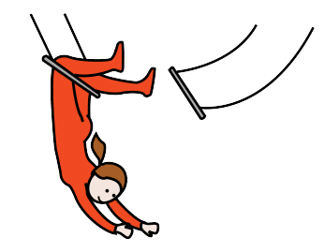

It is a circus show.

Chimera Arts do it. They work in

* Brisbane

**and**

* Northern New South Wales.

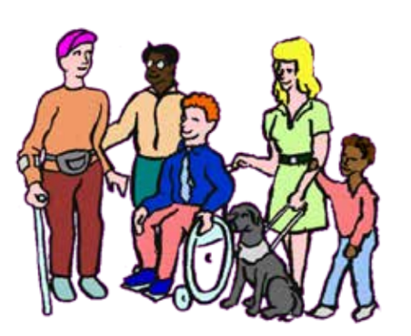A disability can be hard.  
They look at the hard stuff.

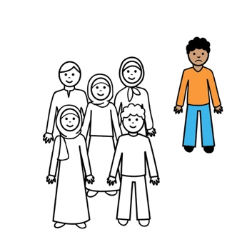

They are alone.

It is hard.

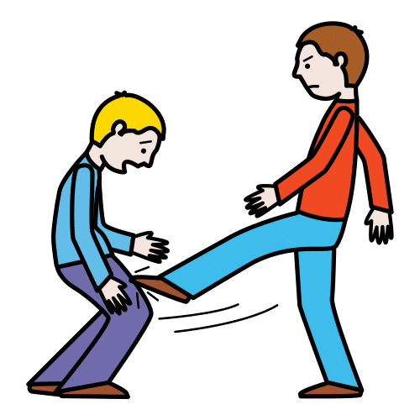They hate people with a disability.

They are hurt.

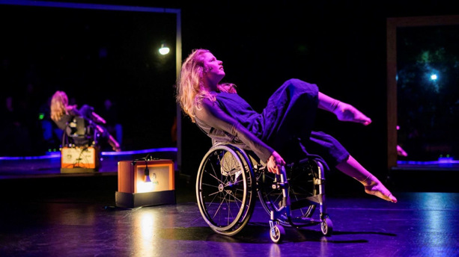**White Noise**

It will go for an hour.



It will be on Thursday 25 September.



It will start at 8 pm.

It will finish at 9 pm.

It will be on Friday 26 September.



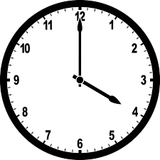

It will start at 4 pm.

It will finish at 5 pm.

It will be in the Diane Cilento Studio.

.

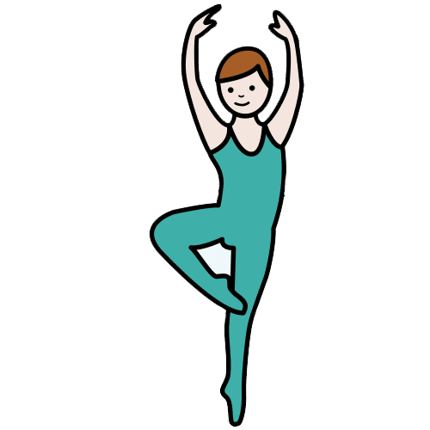It is

* dance

**and**

* circus.

It is done by Touch Compass Dance Theatre.

They are in New Zealand.

It was made by Alisha.

It is a story about her.

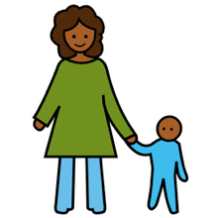

* **A cartoon of a person sitting

  AI-generated content may be incorrect.**She is a mother

**and**

* has a disability.



**Trace**

It will go for 1 hour.



It will be on Thursday 25 September.

It will start at 6 pm.

It will finish at 7 pm.

It will be in the Bille Brown theatre.

.

It will be a short film.

It will be the first time.

It is a dance film.

There will be a **panel**.

They will talk about

* the film
* dance
* who they are.



I can ask a question.

It is done by Sprung Dance Theatre.

They are in Northern New South Wales.

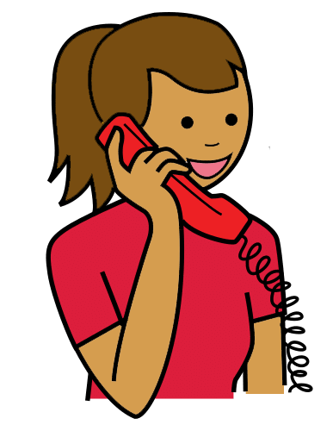**You can talk to us**

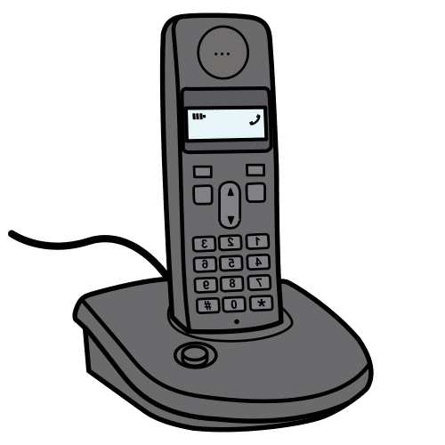You can buy tickets.

You can call Queensland Theatre Box Office.

1800 355 528

**or**



You can go to the website.

[www.undercoverartistfest.com](http://www.undercoverartistfest.com)

You can ask a question.

You can send an email.

[undercoverartist@cpl.org.au](mailto:undercoverartist@cpl.org.au)

This is based on Undercover Artist

Festival 2025 festival program.

Alexandra Buchanan at Always Access wrote this Easy English document.

[alex@alwaysaccess.com.au](mailto:alex@alwaysaccess.com.au)

June 2025

**Images**

Global Symbols

Vecteezy