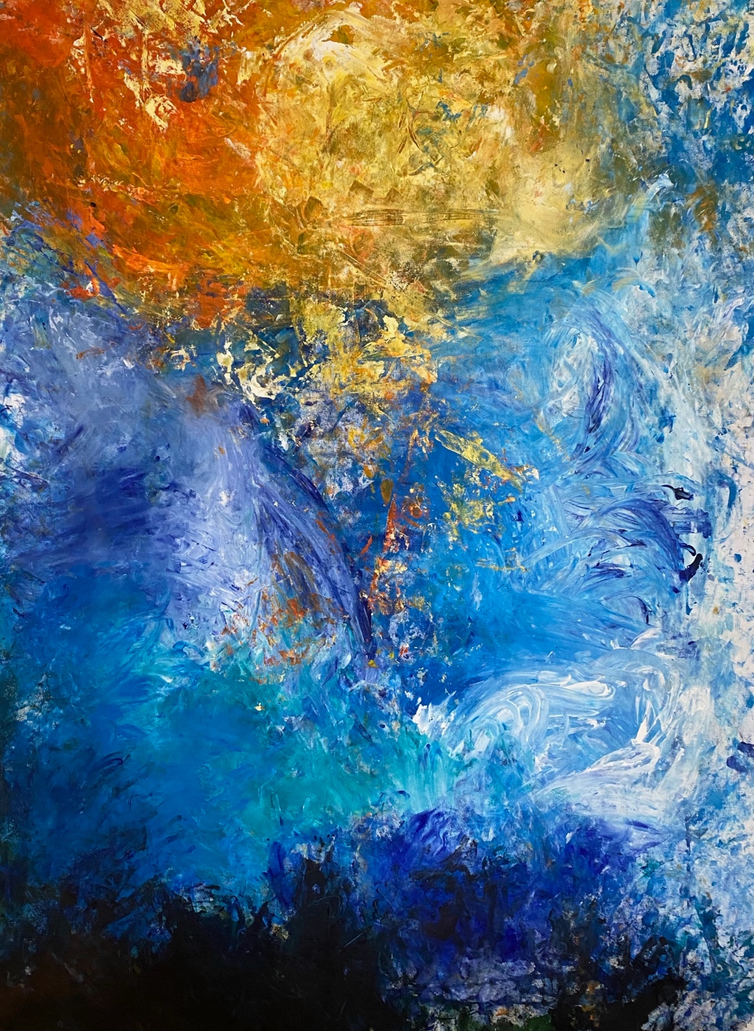

Undercover Artist Program 2025
Book 3 dance and circus


Hard words

This book has some hard words.

The first time we write a hard word
- the word is in blue
- we write what the hard word means.


You can get help with this book

You can get some one to help you

● read this book
● know what this book is about
● find more information.

About this book

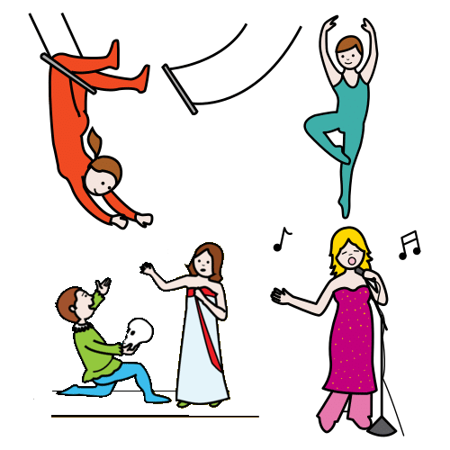
It is about Undercover Artist Festival.
It puts on shows like
- music
- dance
- circus
- comedy.

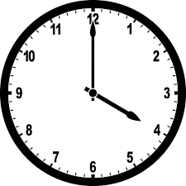
The book will tell you about a show
- when they are on
- where they are on
- what they are about.
There are 3 books
1 comedy and theatre
2 music
3 dance and circus

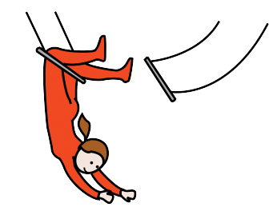
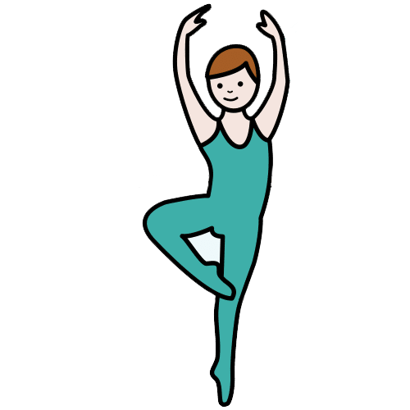
This is book 3.
It is about dance and circus.


We thank the First Nations people.

At the festival

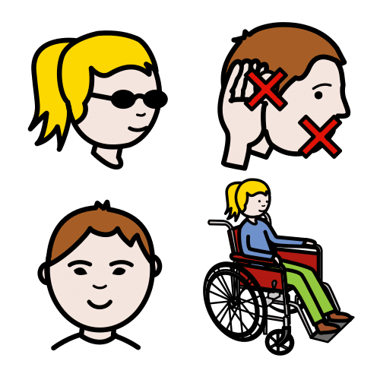

The main artist has a disability.

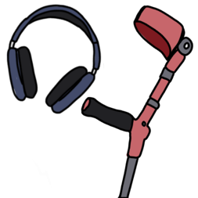
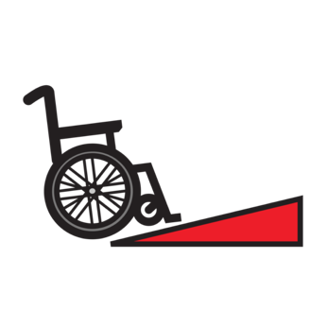
There will be access there.
It is what people with a disability need.
They will tell you in a book later.

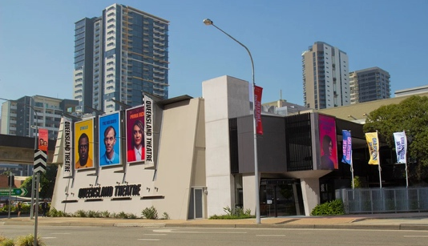
Each show will be at Queensland Theatre.

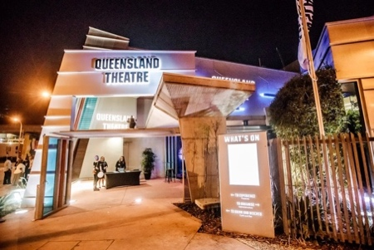
The address is 78 Montague Road.
It is in South Brisbane.

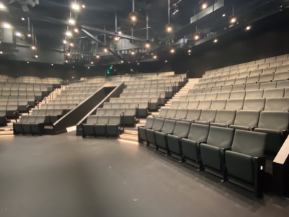
There are two theatres
- The Bille Brown Theatre
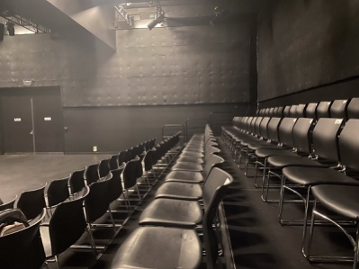
and
- Diane Cilento Studio.


There are content warnings.
These tell you if it can be hard.
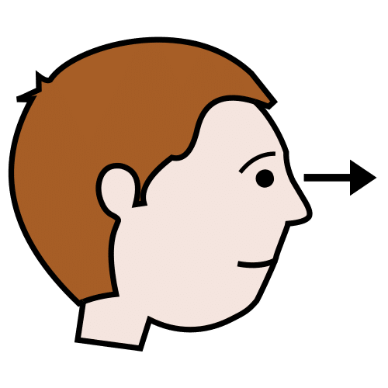
They can be hard to
- see
and
- hear.

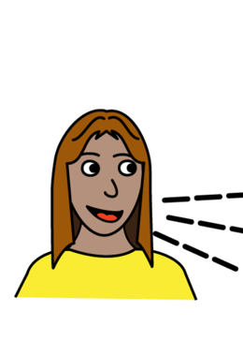
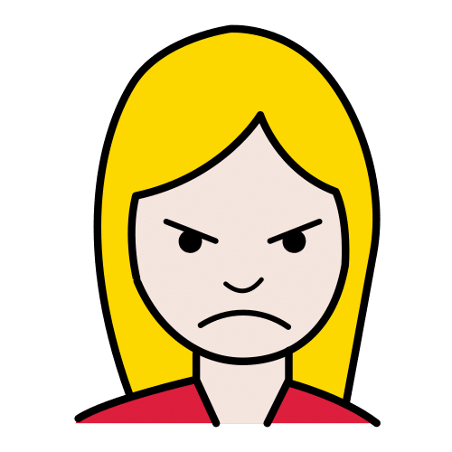
Like
- swear words


- drugs
- black out.

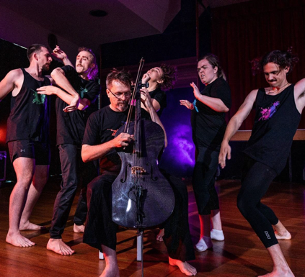
Wired Differently

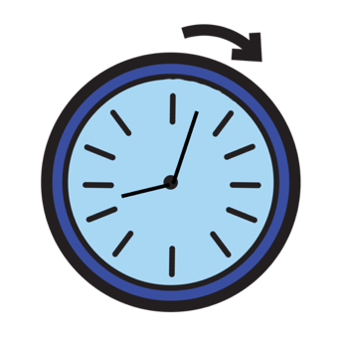

It will go for an hour.

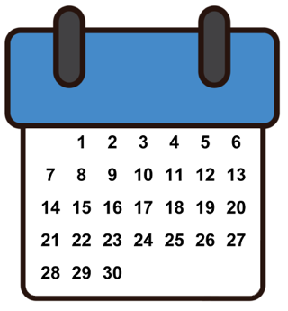

It will be on Monday 22 September.

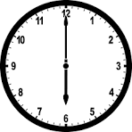
It will start at 6 pm.
It will finish at 7 pm.

It will be on Wednesday 24 September.

It will start at 6 pm.
It will finish at 7 pm.

It will be on Friday 26 September.

It will start at 6 pm.
It will finish at 7 pm.

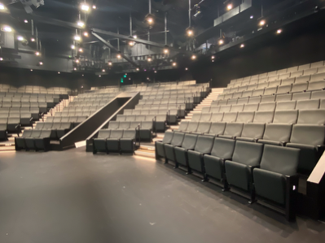
It will be in the Bille Brown theatre.
.

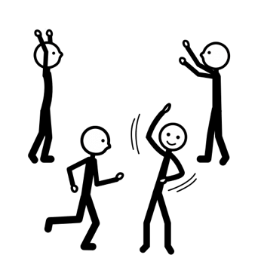
It’s physical theatre.
They use their body to tell the story.

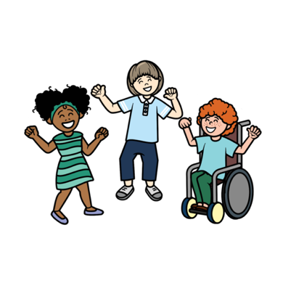
It is done by groups
- Screech Arts
and
- Zen Zen Zo.


They love that we are different.

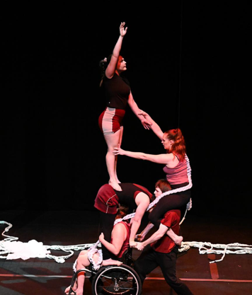

6 Degrees

It will go for an hour.

It will be on Tuesday 23 September.

It will start at 4 pm.
It will finish at 5 pm.

It will be on Wednesday 24 September.

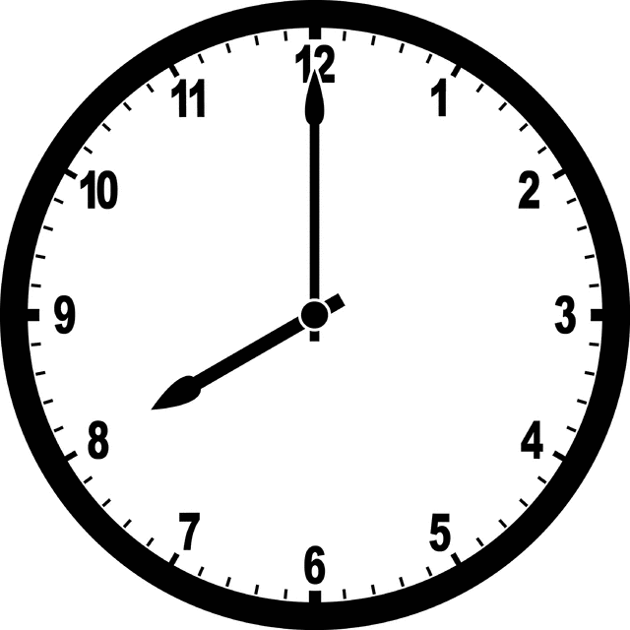
It will start at 8 pm.
It will finish at 9 pm.

It will be in the Diane Cilento Studio.
.

It is a circus show.

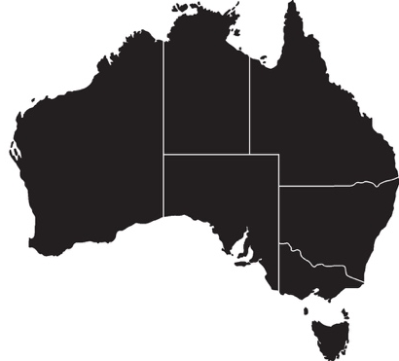
Chimera Arts do it. They work in
- Brisbane
and
- Northern New South Wales.


A disability can be hard.
They look at the hard stuff.

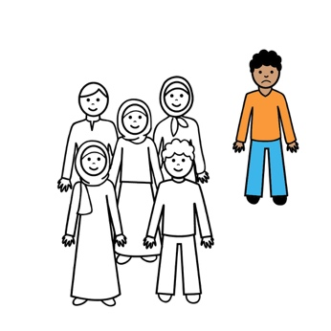
They are alone.
It is hard.

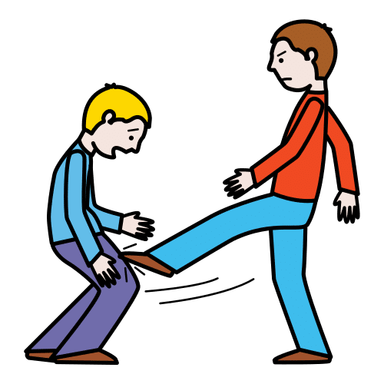
They hate people with a disability.
They are hurt.

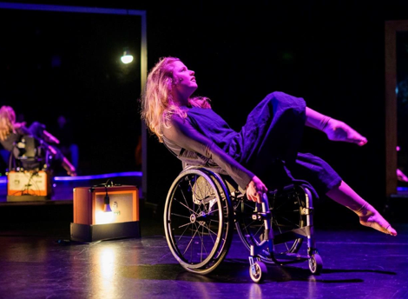
White Noise

It will go for an hour.

It will be on Thursday 25 September.

It will start at 8 pm.
It will finish at 9 pm.

It will be on Friday 26 September.

It will start at 4 pm.
It will finish at 5 pm.

It will be in the Diane Cilento Studio.
.

It is
- dance
and
- circus.


It is done by Touch Compass Dance Theatre.
They are in New Zealand.

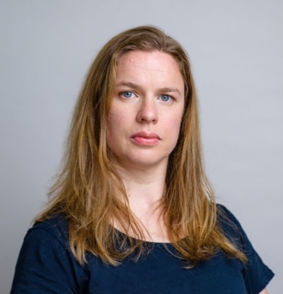

It was made by Alisha.


It is a story about her.
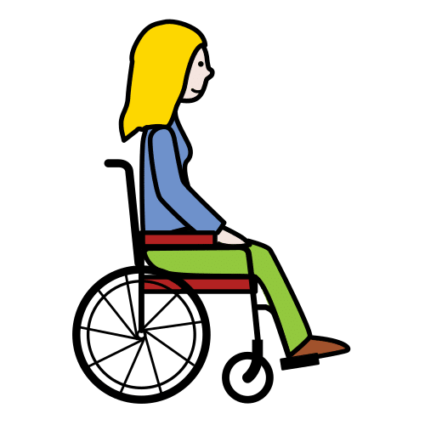
- She is a mother
and
- has a disability.



Trace

It will go for 1 hour.

It will be on Thursday 25 September.
It will start at 6 pm.
It will finish at 7 pm.

It will be in the Bille Brown theatre.
.


It will be a short film.
It will be the first time.

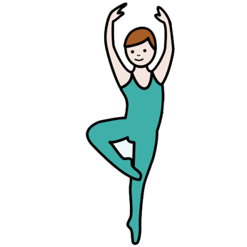
It is a dance film.

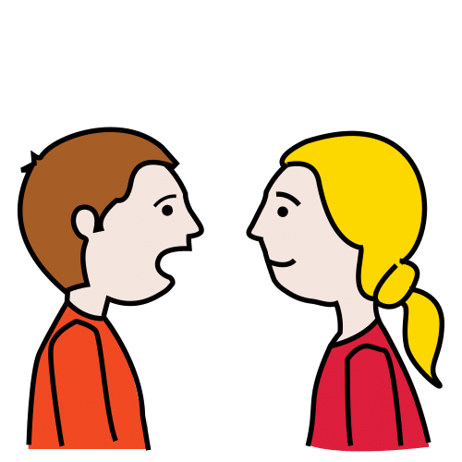
There will be a panel.
They will talk about
- the film
- dance
- who they are.



I can ask a question.

It is done by Sprung Dance Theatre.
They are in Northern New South Wales.

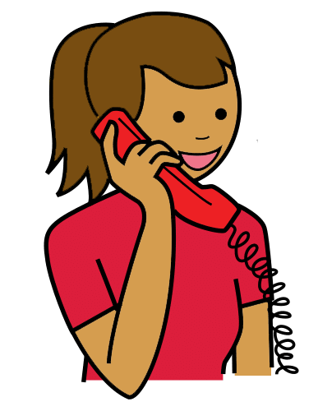
You can talk to us


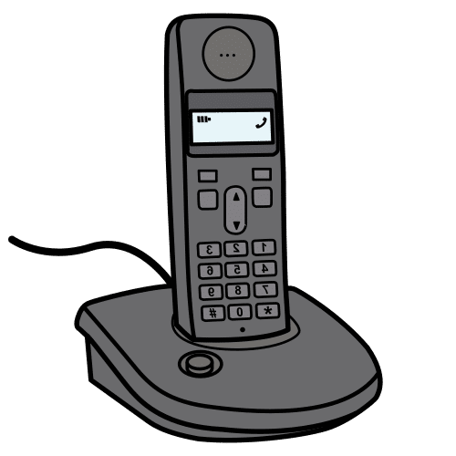
You can buy tickets.
You can call Queensland Theatre Box Office.
1800 355 528

or

You can go to the website.
www.undercoverartistfest.com


You can ask a question.
You can send an email.
undercoverartist@cpl.org.au

This is based on Undercover Artist
Festival 2025 festival program.

Alexandra Buchanan at Always Access wrote this Easy English document.
alex@alwaysaccess.com.au
June 2025

Images
Global Symbols
Vecteezy

