UNDERCOVER ARTIST FESTIVAL 2025

Application Information Pack

Artwork: “My Abstract World” by Annika Strand

Information Pack

This is the information pack for Festival Applications when applying to present at Undercover Artist Festival 2025 (Festival or UAF25).

In this pack, you will find:

* Key dates
* What is Undercover Artist Festival?
* How do I know which program I should apply to?
* Information about the venue
* How do I apply?
* What do I need to prepare?
* Disability-led

Contact

If you have any questions about this Info Pack or your application, email us at [undercoverartist@cpl.org.au](mailto:undercoverartist@cpl.org.au?subject=Undercover%20Artist%20Festival%202025) – please note that the Festival team part-time and will reply as soon as possible.

Contents

Key Dates 4

What is Undercover Artist Festival? 5

How we program 7

Undercover Artist Festival 2025 – The Vision 8

Festival Applications 9

Venue 11

Application Process 13

Support Material 14

Accessibility 15

Need Help? 16

Key Dates

|  |  |
| --- | --- |
| 2024 |  |
| 1 October | Festival Applications Open (Stage One) |
| 29 November | Festival Applications Close |
| 20 December | All artists notified of outcome - shortlisted artists invited to Stage Two Applications. Unsuccessful applicants advised. |
| 2025 |  |
| 31 January | Festival Applications (Stage Two) closes.  Festival programming underway |
| 14 February | Stage Two outcomes - Final artists receive offers and paperwork. All artists notified of outcome. |
| 10 March | Due date for all signed agreements |
| 17 – 21 March | Undercover Artist Festival 2025 photo/ video shoot – details coordinated with artists. Hard deadline for all marketing material. |
| July TBC | UAF25 Program launch. Festival tickets on sale. |
| July – September | Ticket sales period, some marketing activities (media calls, interviews, appearances) may be required. |
| 22 – 27 September | Undercover Artist Festival 2025 |
| 30 – 4 October | Artist Feedback surveys due |
| 11 – 15 October | Final payments and videos/ photos shared with artists. |

What is Undercover Artist Festival?

Undercover Artist Festival is a disability-led performing arts festival. It runs every two years. The Festival is an initiative of Access Arts, Queensland’s leading organisation creating opportunities in the performing and visual arts for people with disability or disadvantage.

Want to know more about Access Arts? Go to our website: [accessarts.org.au](https://accessarts.org.au/)

Access Arts is part of CPL – Choice, Passion, Life. Learn more: [cpl.org.au](https://www.cpl.org.au/)

There are three main program ‘tracks’ during Undercover Artist Festival:

|  |  |  |
| --- | --- | --- |
| **Creative** | Community | Career |
| Disability-led, professional performing arts work. | Community arts performances,  installations for all. | Workshops, panel conversations and professional development. |

When you apply for the Festival, you can apply to the Creative or Community Track. In 2025, we are not accepting applications for the Career Track. Learn more about the Festival Tracks on page 9 in the ‘What we are looking for’ section.

Disability-led

Undercover Artist Festival is disability-led. If you want to know more about what this means, please download our guide [here](https://undercoverartistfest.com/wp-content/uploads/2021/02/2102_UAF_What-Is-Disability-Led_FINAL.docx) for more information.

If you are applying for the Creative Track, you need to show us that your project is:

* disability-led or d/Deaf-led, or:
* Working towards disability-led or d/Deaf-led practice.

We know that not all groups are managed by people with disability. We support ally-led groups. If your company is not disability-led, your project may still be. Check the ‘What is disability-led?’ Guide on our website: [undercoverartistfest.com/what-is-disability-led](https://undercoverartistfest.com/what-is-disability-led/)

If your project is not yet disability-led, tell us how you and your team are working towards a disability-led future.

Example: “Suzie is interested in directing shows in future and wants to learn how to direct by observing our director, Kai, and being mentored by them.”

Ally-led projects are important. We support ally-led creative projects. The Creative Track focuses on disability-led works to create new opportunities for d/Deaf and disabled talent to lead. It’s about adding more opportunities – not taking any away.

If you are applying for theCommunity Track, your project can be led by people with or without disability. We encourage community groups to think about how they can center disabled and d/Deaf voices.

How we program

We will select shows and artists in two ways:

1. Festival Applications
2. Our Research

We combine Festival Applications and research to create a program that reflects our community. This helps us make sure our Festival program has something for everyone.

We program based on three key questions:

* Is this project exciting?
* Does it fit the programming theme of **Push it!**
* Does it fit well with the rest of the program?

The strongest applications answer those questions. They also clearly respond to the 2025 Festival theme, **Push it!**. Learn more about the 2025 Festival theme on page 8 in the ‘Undercover Artist Festival 2025 – The Vision’ section.

Is it ‘open access’?

‘Open access’ means that everyone who applies gets in. Undercover Artist Festival is notopen access. Not every artist who applies will be chosen. Sadly, we just don’t have the space, time and resources to accept everyone.

Undercover Artist Festival 2025 – The Vision

Welcome to Undercover Artist Festival 2025 - where the theme is not just a phrase but a call-to-action, a challenge, and an encouragement to artists to Push it!

The Festival will run from 22 – 27 September 2025 in partnership with Queensland Theatre and Brisbane Festival, and will celebrate 10 years of outstanding performing arts by disabled and d/Deaf artists.

What does Push It!mean? We want artists to interpret this theme in a way that feels right to you. It’s meant to be abstract, and we want d/Deaf, disabled and neurodivergent artists to feel confident and ready to Push It!

Here are some examples of what Push It!can mean:

* Pushing the boundaries - Challenging the status quo and what's possible.
* Pushing buttons - Evoking emotions, provoking thought, and stirring reactions.
* Pushing to be better, stronger and braver - Personal growth as an artist.
* Pushing each other - A community of artists lifting each other up.
* Pushing for change - Being a voice for change, advocating through art.
* Pushing in - Making space for ourselves in a crowded world.
* Pushing the limits - redefining what's achievable.

There is no right or wrong way to interpret the theme.

Festival Applications

2025 marks ten years of Undercover Artist Festival, and we’re here to celebrate ten years of Pushing It! The Festival is looking for incredible national and local talent so we can support the development of new work and early career talent in the performing arts.

What we’re looking for

We want shows that are:

|  |  |  |  |
| --- | --- | --- | --- |
| Bold | Exciting | Authentic | Accessible |
| Challenging | Sexy | Funny | Heartwarming |
| Honest | Wild | Moving | Gentle |

You don’t have to tell your life story – if you want to, you can! But we do want to see more shows that don’t only focus on disability.

We especially want to see Deaf-led and First Nations-led projects apply to be part of our Festival.

What we are not looking for

* ‘Disability as tragedy’ stories
* Shows about disability by only non-disabled people

All Festival Applications should be able to connect to the Push it theme in one way or another. Learn more about the 2025 Festival Theme on page 8 in the ‘Undercover Artist Festival 2025 – The Vision’ section.

If you’re not sure if your work is suitable, please ask us: [undercoverartist@cpl.org.au](mailto:undercoverartist@cpl.org.au)

 Creative Track

Shows in the Creative Track are:

* Professional
* High-quality
* Ready-to-go
* No longer than 70 minutes long
* Pay professional artists fairly

The Creative Track does **not** present works-in-progress readings or showings. If the Festival would be the premiere of your show, you need to have a strong plan to make sure it’s ready in time.

 Community Track

* Is for amateur and ‘just for fun’ artists and groups
* Is supportive
* Celebrates the heart of our disability arts community

You can pitch a workshop or a performance. You will need to have a clear idea.

Shows can be up to 30 minutes long. Workshops can be up to 2 hours long (120 mins).   
Have an idea that isn’t a show or workshop? Get in touch: [undercoverartist@cpl.org.au](mailto:undercoverartist@cpl.org.au)

 Career Track

* Panel talks
* Workshops
* Work-in-progress showings or readings

In 2025, we will not be taking applications for Career Track events. If you have an idea you want to pitch to us, you can email us at [undercoverartist@cpl.org.au](mailto:undercoverartist@cpl.org.au)

Venue

Undercover Artist Festival will be held at Queensland Theatre (78 Montague Road, South Brisbane). Please do not contact Queensland Theatre. Due to the number of applications, all questions must come to the Undercover Artist team. You can contact us on [undercoverartist@cpl.org.au](mailto:undercoverartist@cpl.org.au)

Queensland Theatre has two main performance spaces –

* The Bille Brown Theatre, and
* The Diane Cilento Studio.

In Stage Two of the application process, we will ask artists who are shortlisted to tell us more about which stage is best for your work.

Bille Brown Theatre:

The Bille Brown Theatre features a corner stage layout with seating for around 310 patrons. The audience sits in three sections that wrap around the action on stage.

1 Photo by Masimba Sasa

On the right is an image of Deaf Indigenous Dance Group performing at the 2023 Undercover Artist Festival.

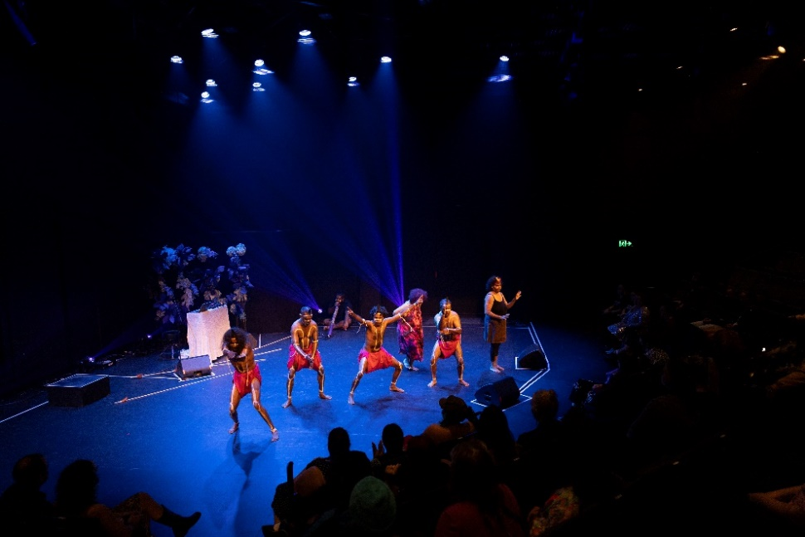

Diane Cilento Studio:

The Diane Cilento Studio is a black box theatre studio with end-on seating for around 70 patrons.

End-on seating means that there is one section of seats facing the stage. You can see this in the image on the right:

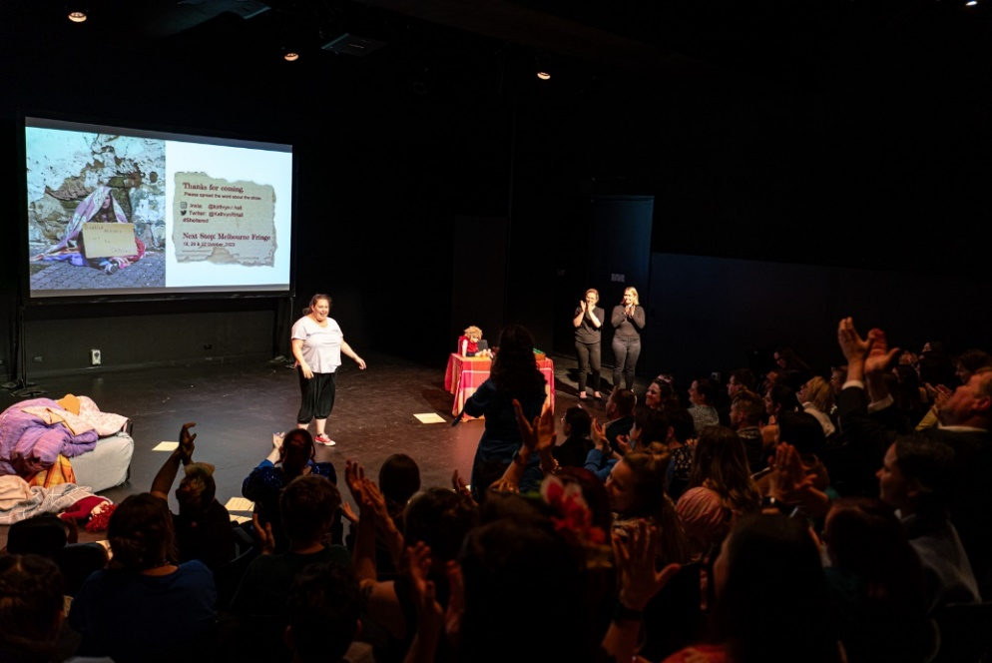

**2 Photo by Jade Ellis**

In the image above, Kathryn Hall has just finished performing *Sheltered* at Undercover Artist Festival 2023. She stands in the centre of the stage in front of a screen, with Auslan interpreters standing to the far right. The audience is applauding – some standing – in one section directly in front of Kathryn.

Application Process

The Festival Application process will run in two stages.

Stage one: Complete you Festival Application form and submit to Undercover Artist Festival

Stage two: We will contact you if you are shortlisted. We will then ask you to provide more information about your work.

Ways to apply

|  |  |
| --- | --- |
| Online | Apply via the [**webform**](https://forms.office.com/r/u9Y1EqWCDF) on the Undercover Artist Festival website before 11:59pm, Friday 29 November. If the Online form does not meet your access needs, we have other options. |
| Via Email | We accept completed Festival Applications via email - [available in Black & White, and Large text](https://bit.ly/3TzgTTI)  You can send us:   * Completed Word document Festival application form * Auslan Video * Audio/ Voice recording   Video and voice recordings must answer all the questions in the application form. See above for Black & White, and Large Text versions.  Email your application to [undercoverartist@cpl.org.au](mailto:undercoverartist@cpl.org.au) before 11:59pm, Friday 29 November with “2025 UAF – Your Name” in the subject line. Your email will need to include a link to a Google Drive, OneDrive or DropBox folder with all of your support materials. See Support Material (page 14) for more information |
| Phone or Video Call Interview | If other methods of applying do not work for you, you can request a phone or video call interview. Email us at [undercoverartist@cpl.org.au](mailto:undercoverartist@cpl.org.au) with “2025 UAF Interview” in the subject line before 1st November 2024 so we can book a meeting with you.  Calls will be around 15 minutes long. We’ll ask you questions from the form. Support people are welcome to join. We’ll ask you to share support material with us before the call. |

Support Material

When you apply for any opportunity, you should always pretend that the people reading your application don’t know who you are. This means you will need to tell us who you are, what you do, and how good you are at doing it.

You will need to give us a link to a Google Drive, OneDrive or DropBox folder with all your support material in one place.

|  |  |
| --- | --- |
| You will need to include: | |
| CV/Resume | * A CV or Resume for each artist and arts worker involved in your work. * Please submit all biographies in one single word document. * You don’t need to include support workers. |
| Hero Image | * A hero image is the main photo you use to tell people about your work. |
| Letters of Support | * At least two letters of support. * Should be written by people who know your work. |
| We recommend you include: | |
| Any plans | * Any lighting, sound, or set plans that show the scale, design and feel of your work. |
| Optional: | |
| A trailer video or ‘sizzle reel’ | * No more than 2 mins long * video files should be in either .mp3, .mp4, .mov or .wav formats or website links |
| Photos | * No more than 6 photos * Photographs in .jpg or.jpeg format |
| Script excerpts | * No more than 3 A4 pages long |
| Reviews and testimonials | * No more than 2 A4 pages long |

Accessibility

When you apply, you can tell us how you communicate. If you move on to Stage Two, we will ask you to complete an Access Rider (or an ‘Access Needs’ form). This will help us meet your needs to the best of our ability.

Please note: completing an Access Rider is essential for all projects.

Will my disability or deafness affect my application?

No. You will not be judged on the basis of disability.

We program with diversity of disability experience in mind. This means that we will work to make sure our program includes d/Deaf artists, disabled artists, chronically ill artists, artists with mental illness, and neurodivergent artists of all backgrounds across all performing arts forms.

Who can apply?

At Undercover Artist Festival, we use ‘d/Deaf and disabled artists’. This term includes:

* People who identify as disabled
* Neurodivergent people
* People with mental illness
* People with chronic illness

The Festival uses identity-first and person-first language as we know everyone is different. We will always use the language you prefer when promoting you and your work.

Need Help?

If you have questions after reading this guide, please email us at [undercoverartist@cpl.org.au](mailto:undercoverartist@cpl.org.au) and will be in touch as soon as we can. Please note, the Festival team works part-time.

Extra Resources

The Undercover Artist Festival website has a page dedicated to artist resources.

[Artist Resources - Undercover Artist (undercoverartistfest.com)](https://undercoverartistfest.com/artist-resources/)