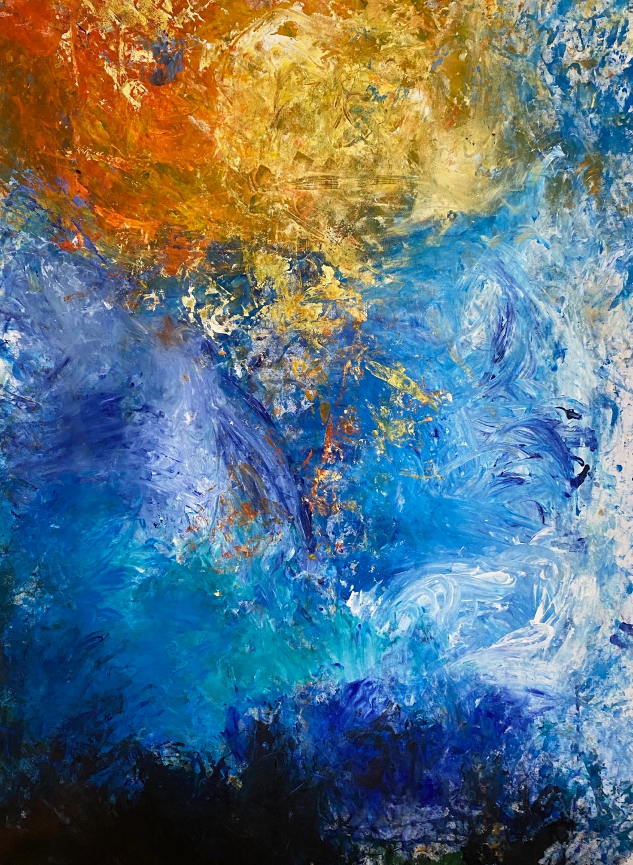

**Undercover Artist Program 2025**

**Wunder Sounds**

**

This book has some hard words.

The first time we write a hard word

* the word is in **blue**
* we write what the hard word means.

**

You can get some one to help you

● read this book

● know what this book is about

● find more information.

**

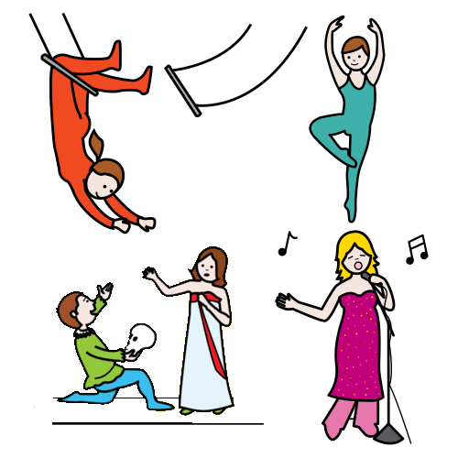It is about Undercover Artist Festival.

It puts on shows like

* music
* dance
* circus
* comedy.

The book will tell you about a show

* when they are on
* where they are on
* what they are about.

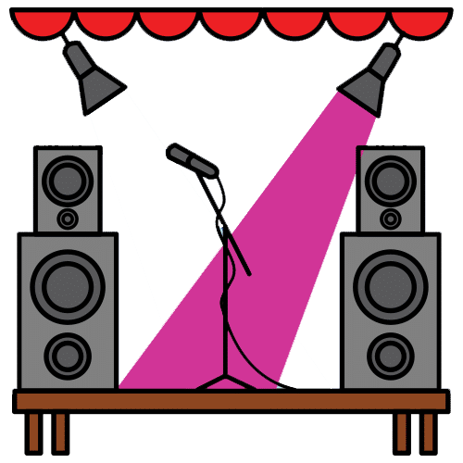

This is book is for Wunder Sounds.

We thank the First Nations people.

**At the festival**

The main artist has a disability.

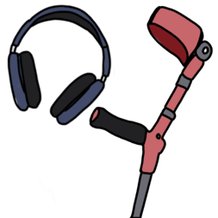

There will be **access** there.

It is what people with a disability need.

They will tell you in a book later.

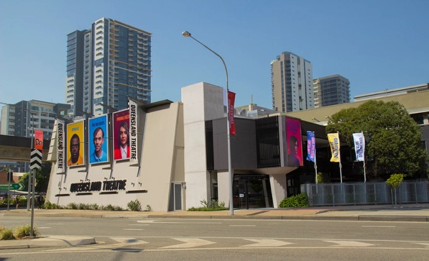Each show will be at Queensland Theatre.

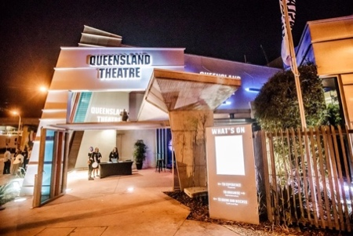The address is 78 Montague Road.

It is in South Brisbane.

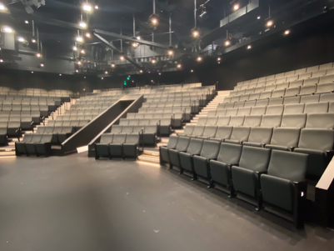There are two theatres

* The Bille Brown Theatre

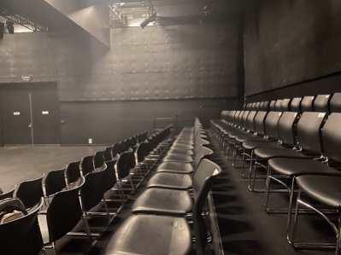**and**

* Diane Cilento Studio.

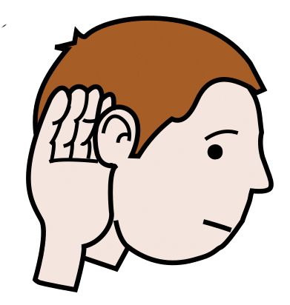There are **content warnings**.

These tell you if it can be hard.

They can be hard to

* see

**and**

* hear.

Like

* swear words
* A syringe with a red cap

  AI-generated content may be incorrect.A group of pills and tablets

  AI-generated content may be incorrect.drugs
* black out.

**Wunder Sounds**

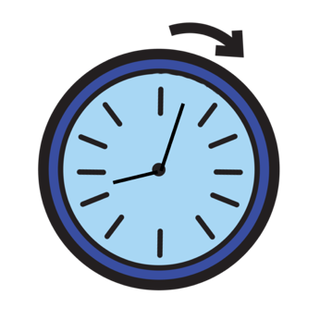

It will go for 2 hours.

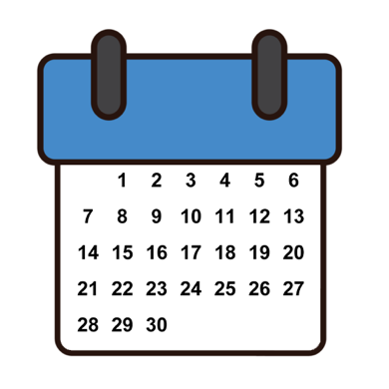

It will be on Saturday 27 September.

It will start at 5:30 pm.

It will finish at 7:30 pm.

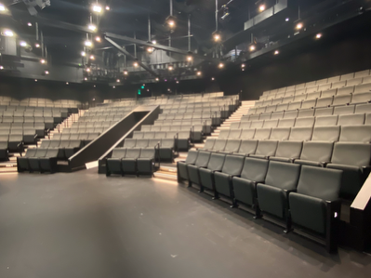

It will be in the Bille Brown theatre.

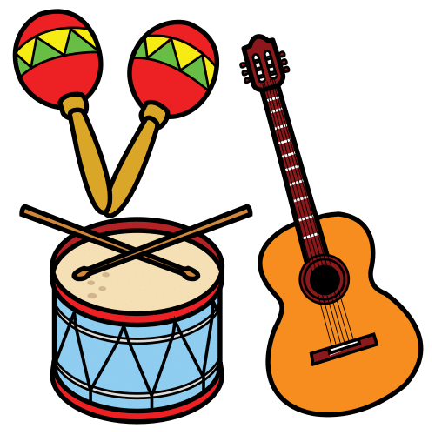It is music.

There will be 4 music shows.

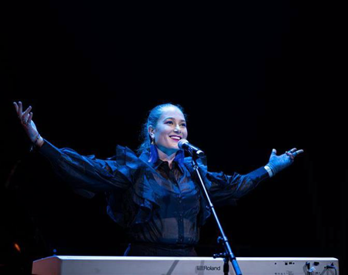Emma Tomlinson sings pop

**and** wrote her music.

There is 3 people on stage.

They play the didgeridoo **and** guitar.

Jungaji is a First Nations man.

* He wrote his songs

**and**

* he will sing.

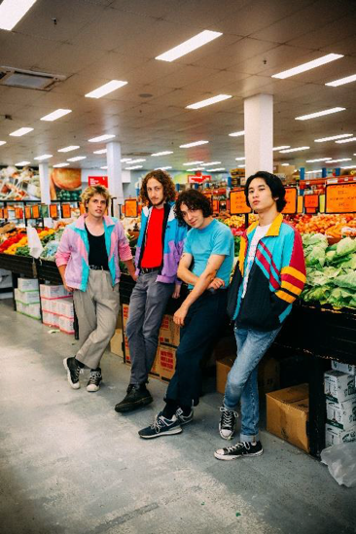SAMMM is a band.

There are 4 people. The music is

* punk rock

**and**

* their words are true.

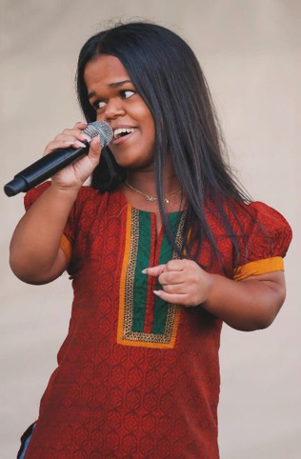Nethra is a singer

**and**

she was on the Voice in 2024.

There are content warnings. Like

* swear words
* drugs.

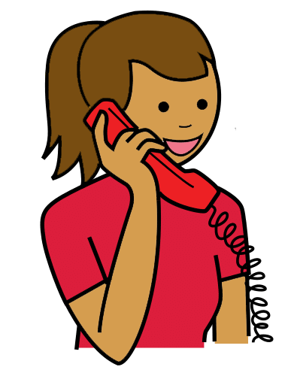**You can talk to us**

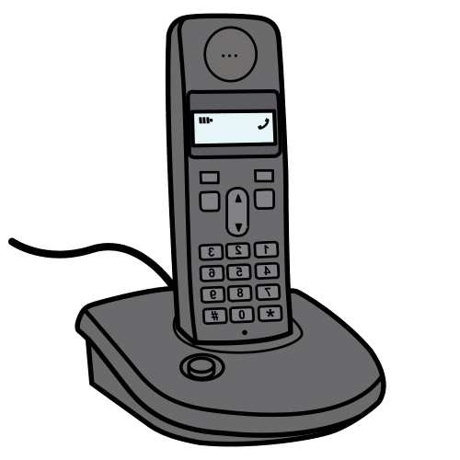You can buy tickets.

You can call Queensland Theatre Box Office.

1800 355 528

**or**



You can go to the website.

[www.undercoverartistfest.com](http://www.undercoverartistfest.com)

You can ask a question.

You can send an email.

[undercoverartist@cpl.org.au](mailto:undercoverartist@cpl.org.au)

This is based on Undercover Artist

Festival 2025 festival program.

Alexandra Buchanan at Always Access wrote this Easy English document.

[alex@alwaysaccess.com.au](mailto:alex@alwaysaccess.com.au)

June 2025

**Images**

Global Symbols

Vecteezy