Undercover Artist Festival
Visual Story

Contents
About Undercover Artist Festival 3
Getting to the Venue 4
Arriving at the Undercover Artist Festival 5
The Box Office 6
The Courtyard 7
The Foyer & Bar 8
Bathrooms 9
Quiet Space 10
Performance Spaces 11
The Diane Cilento Studio 12
The Bille Brown Theatre 13
Considerations 14
Neet to Contact Us? 15

Acknowledgement of Country
Undercover Artist acknowledges the Traditional Custodians of country throughout Australia and we pay our respects to Elders, past, present, and emerging. We are committed to honouring Aboriginal and Torres Strait Islander peoples and their unique cultural and spiritual relationship to land, water and seas and their rich contribution to society.

About Undercover Artist Festival
I am going to Undercover Artist Festival to see and celebrate outstanding work by artists with disability!

Undercover Artist is a disability-led performing arts organisation, and this Festival is a platform for artists to showcase their true, authentic selves.

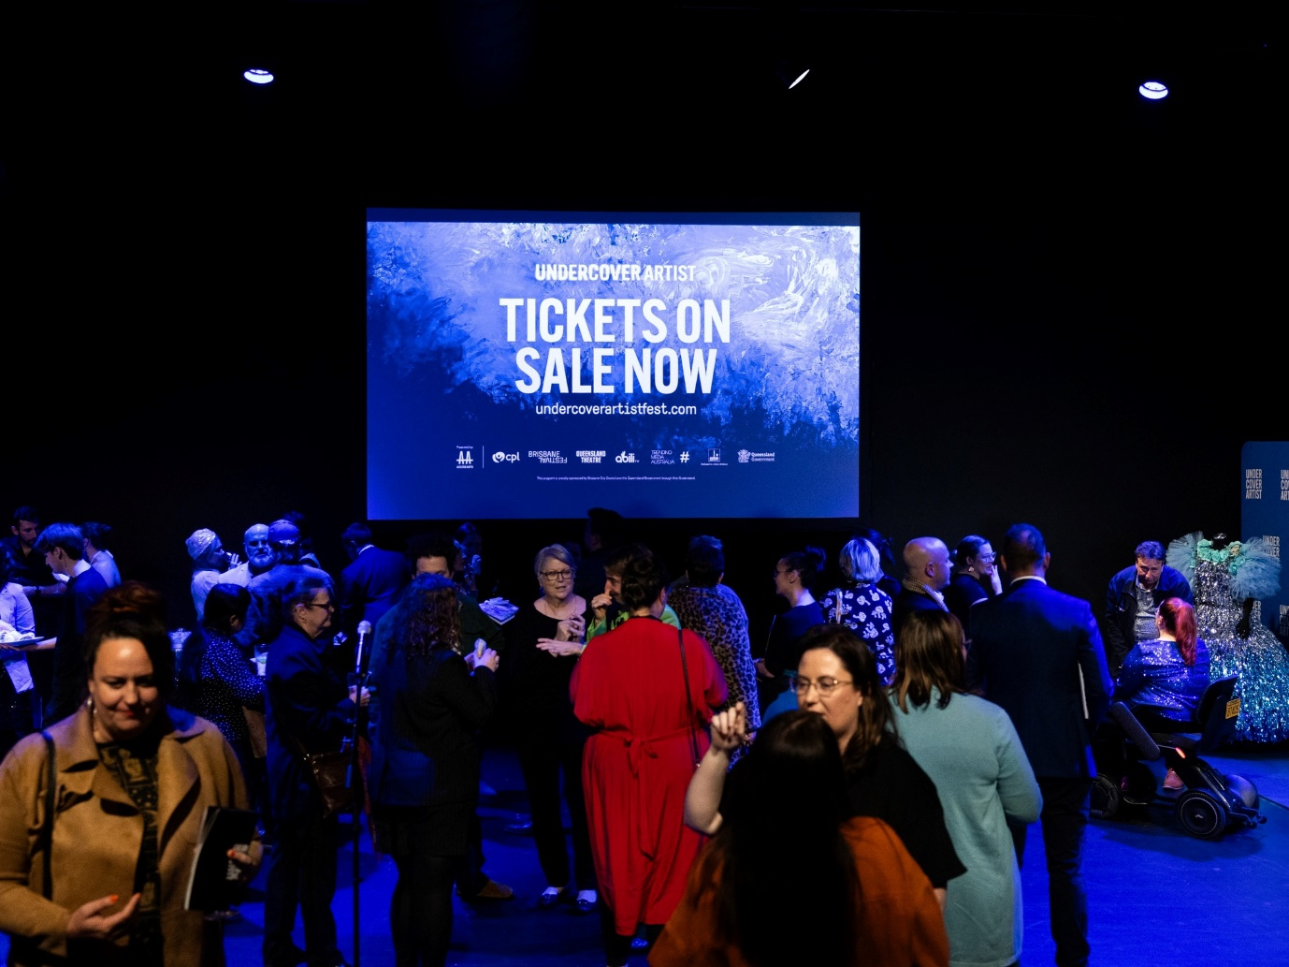

Image: The Undercover Artist Festival Launch party. People are mingling in the Diane Cilento Studio under large digital screen. White text over a blue background reads ‘UNDERCOVER ARTIST TICKETS ON SALE NOW’. Photo by Cinnamon Smith.

Getting to the Venue
Undercover Artist Festival is hosted at the Queensland Theatre.
The building is on Montague Road, with the main entrance at 12 Boundary St, South Brisbane.

The venue includes:

• A Loading Zone for drop-off and pick-up

• Paid undercover parking

• Nearby Council parking

• A nearby bus stop, on Merivale Street

More information about getting to the venue, including photos, is available from the Queensland Theatre website: https://queenslandtheatre.com.au/visit

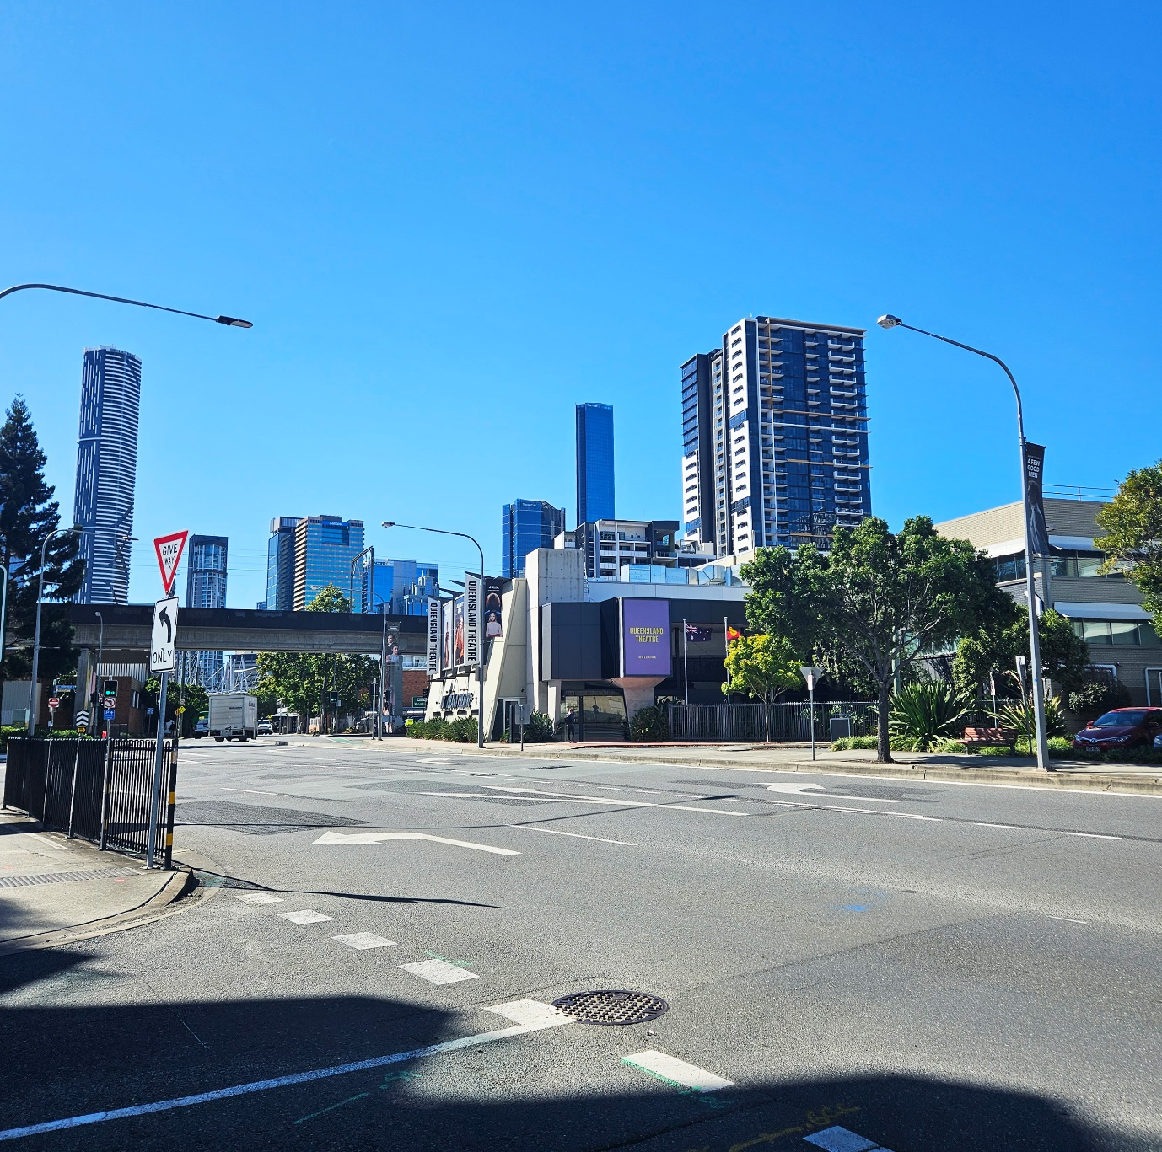

Image: Looking towards the Queensland Theatre, from Montague Road.

Arriving at the Undercover Artist Festival
Entry into the Queensland Theatre is through a glass sliding door.

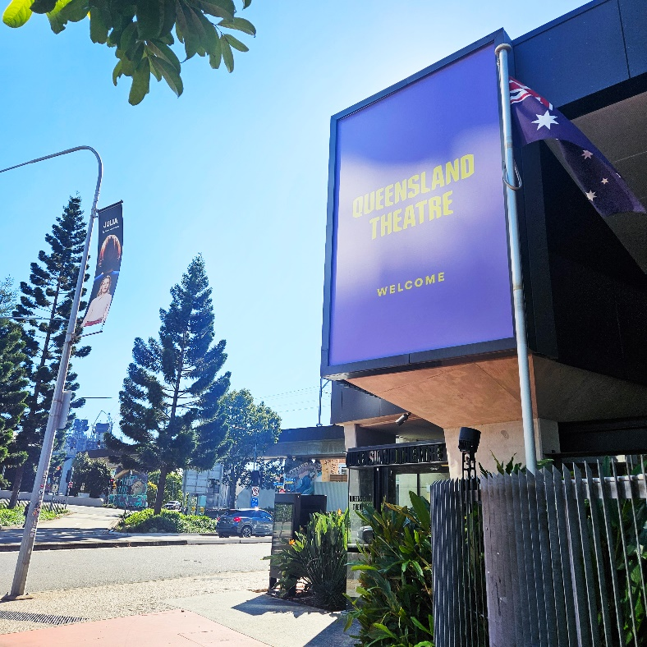

Image: The entry is under a large purple ‘WELCOME’ sign.

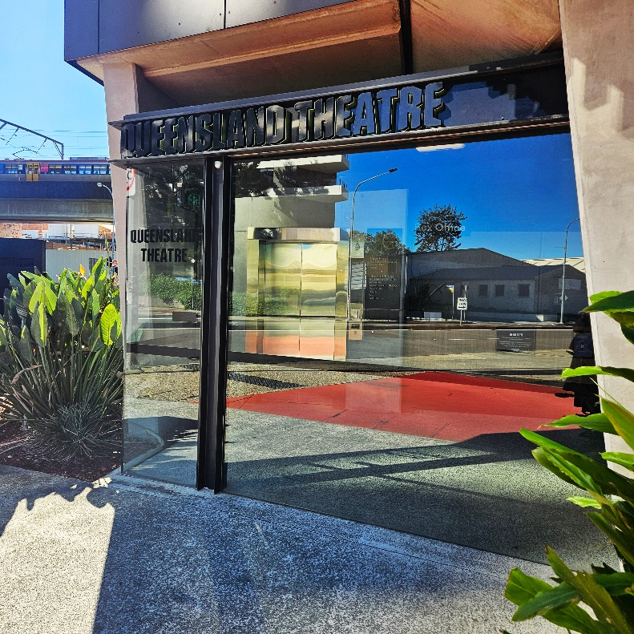

Image: Outside the entry into the venue. The glass door will open automatically.

The Box Office
Through the glass sliding door is the Box Office. This is the best place to go if I have any questions about the venue or my tickets.

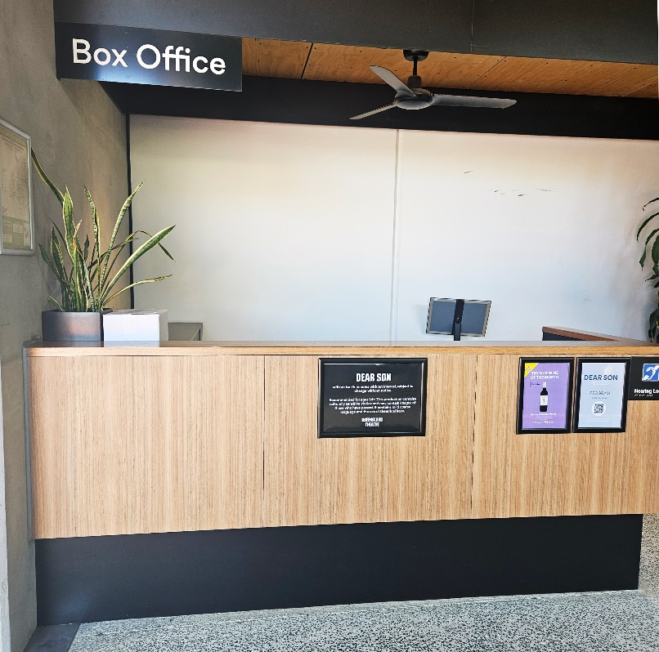

Image: The Queensland Theatre Box Office, just inside the entry. Friendly staff will be available for assistance behind the wooden desk.

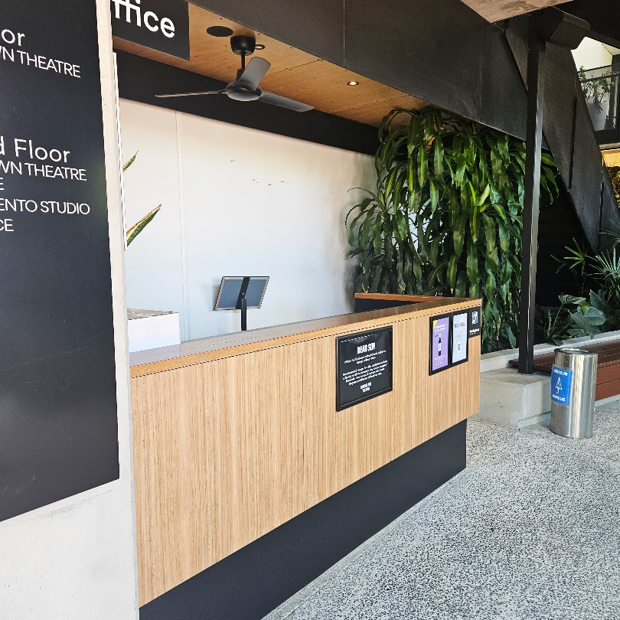

Image: The Box Office wooden desk, leading into the Courtyard. An additional counter will also be available during the Festival, at a lower height.

The Courtyard
To the right of the Box Office is the Courtyard. This is an outdoor area and may feel busy with people before and after each performance.

If I have questions while at the Festival, there are friendly volunteers who can help. They wear vibrant blue t-shirts with the Undercover Artist logo.

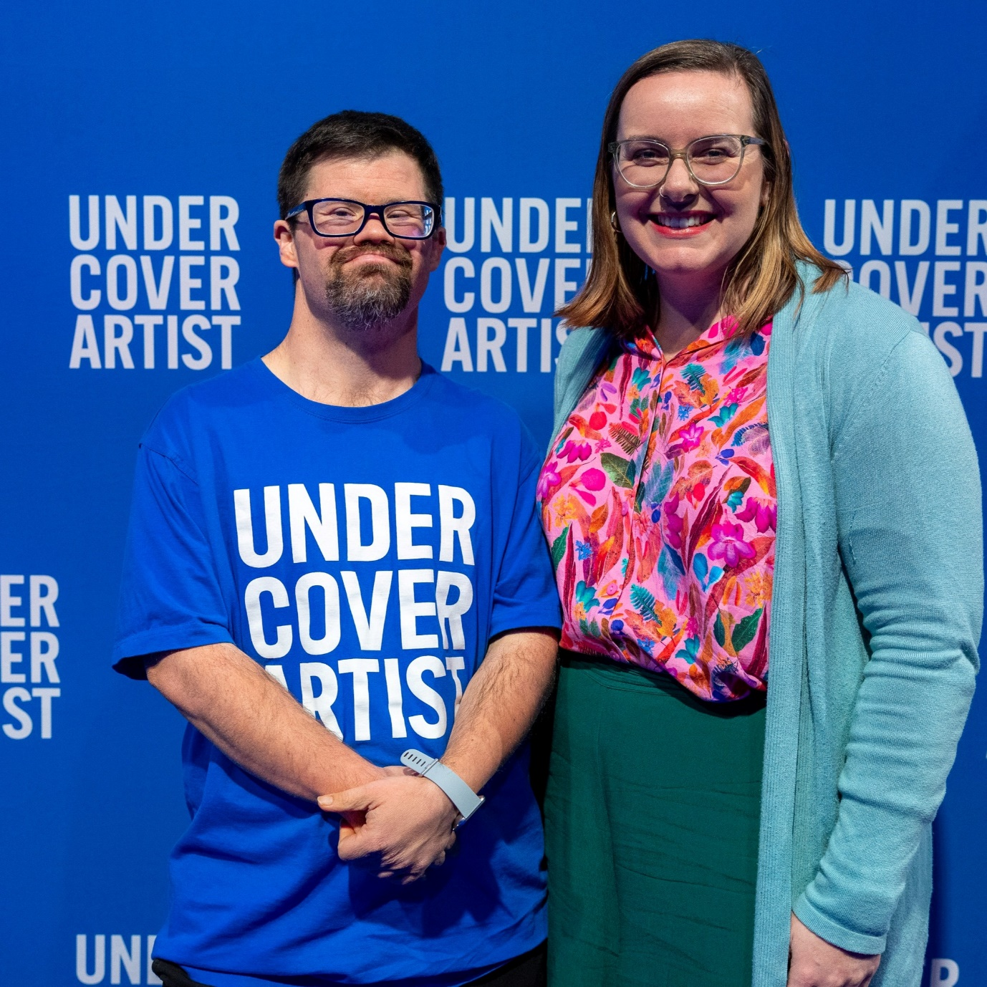

Image: A person wearing the blue Undercover Artist volunteer t-shirt.

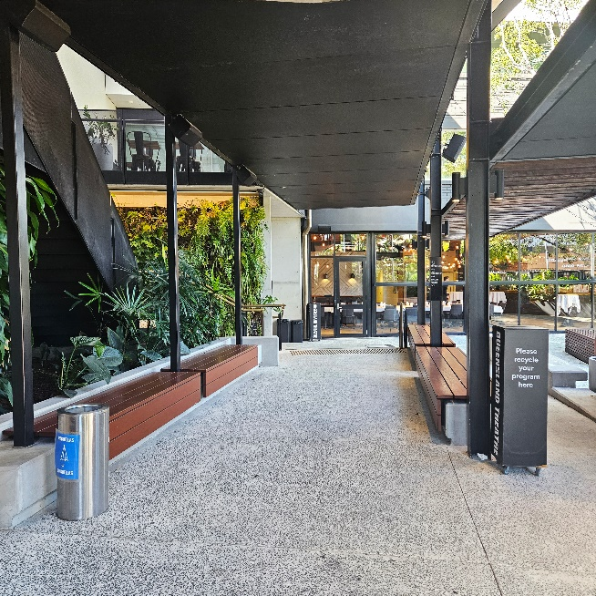

Image: The Courtyard, immediately to the right of the Box Office. This undercover area has bench seating, steps and a ramp that lead to the Foyer.

The Foyer & Bar
The Courtyard leads into the Foyer. This is an indoor area where I can find the Bar, bathrooms and the Quiet Space.

The Bar serves a variety of food and drinks. This area may:

• Feel busy with people before and after each performance.

• Smell of light meals such as toasties and savoury pastries.

• Feel cool in temperature, especially in the evenings, because the Courtyard and the Foyer spaces flow freely into each other.

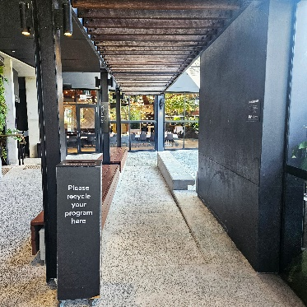

Image: The ramp from the Courtyard, leading to the Foyer and Bar.

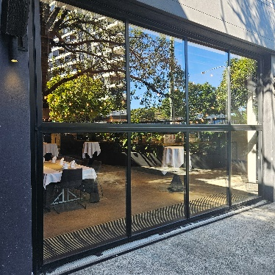

Image: Large glass windows that will be raised during the event, so that people can move easily between the Courtyard and the Foyer.

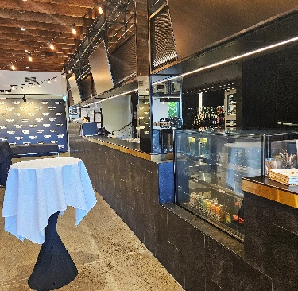

Image: The Bar, on the right side of the Foyer.

Bathrooms
There are Female, Male and All User/Accessible bathrooms at the venue that can be found in the Foyer near the Bar. Inside the Female bathroom are five stalls, including one ambulant stall.

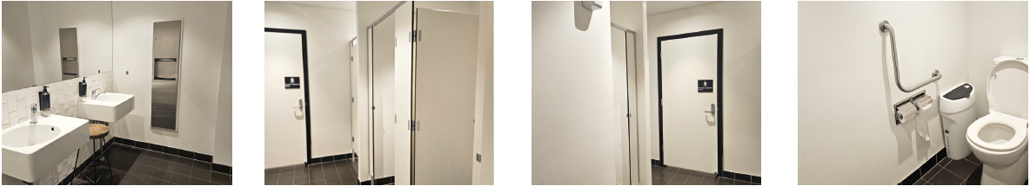

Images: Inside the women’s bathroom. Towards the far back wall is the ambulant toilet.

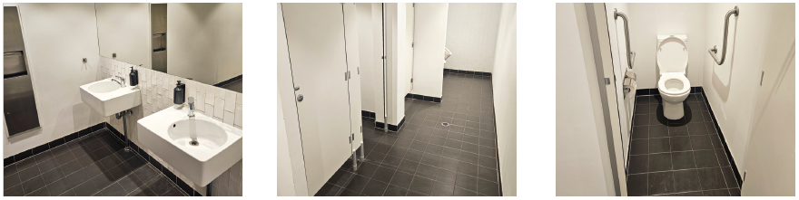

Images: Inside the men’s bathroom, with the ambulant cubicle to the left. There are two urinals at the end, past the toilet stalls.

There is also one All User/Accessible bathroom. Inside this bathroom there is a handrail next to the toilet seat, a sink with a swivel mixer tap and a sharps disposal box.

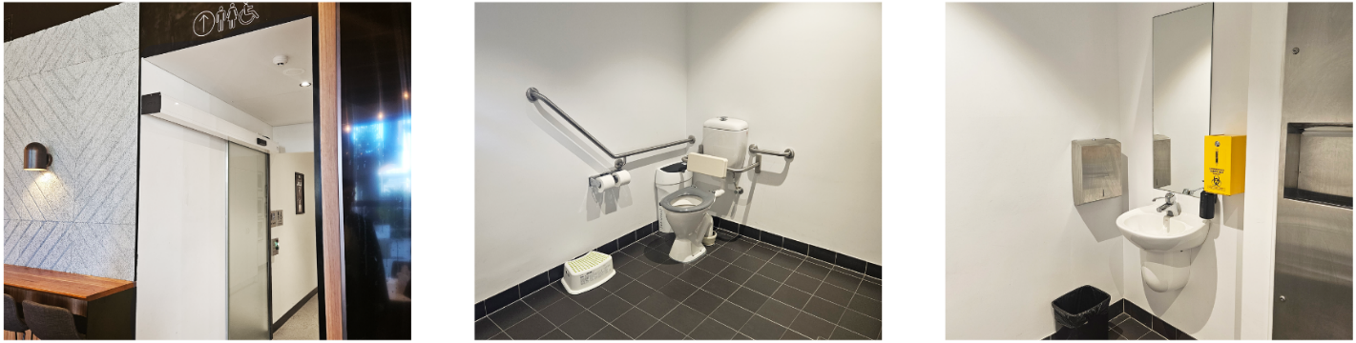

Images: The corridor leading to and inside the All User/Accessible bathroom. The bathroom door is accessible by a push-button.

Quiet Space
At the end of the Bar, at the beginning of the corridor to the left is a Quiet Space.

The Quiet Space is available for anyone who is feeling overwhelmed, overstimulated or just needs a break from the Festival excitement. This room will be set up with soft lighting, seating, sensory objects and calming activities.

The friendly volunteers are available to guide me to this room, where I can stay as long as I need.

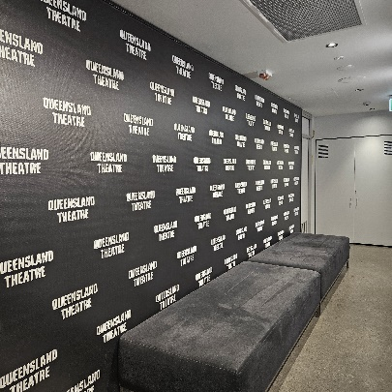

Image: Just outside the corridor, at the end of the Bar.

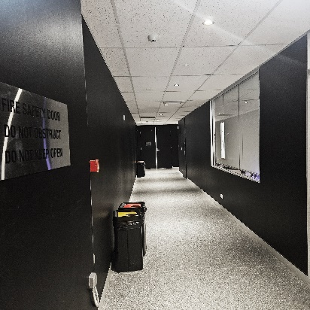

Image: The corridor, leading towards the Diane Cilento Studio. The Quiet Space is the room on the right, with the blinds down.

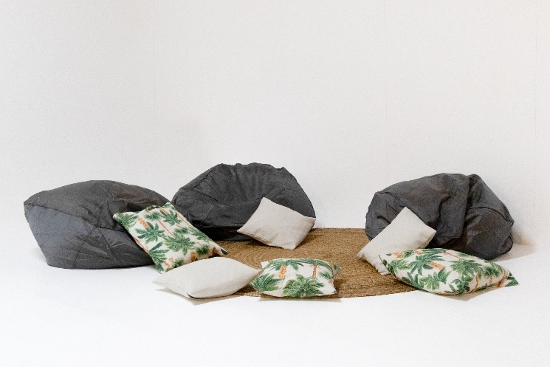

Image: An example of the beanbags and cushions inside the Quiet Space.

Performance Spaces
The Undercover Artist Festival program and performances will be held in either:

- The Diane Cilento Studio

2. The Bille Brown Theatre

The Diane Cilento Studio and the Bille Brown Theatre doors will open approximately 15 minutes before each performance, so I can find my seat.

If I need extra time to navigate the theatre and settle in, I can ask the friendly Box Office staff or volunteers who can help me.

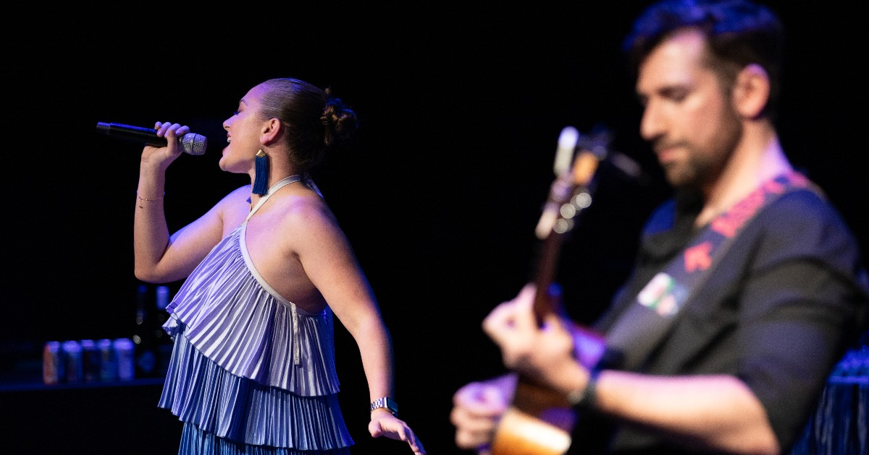

Image: Singer Emma Tomlinson and a guitarist performing at the Under Cover Artist Festival launch party. Photo by Cinnamon Smith.

The Diane Cilento Studio
The Diane Cilento Studio has one entrance, which can be found at the end of the Bar, down the corridor to the left (past the Quiet Room).

When the doors open, ushers will check my tickets and guide me to my seat.

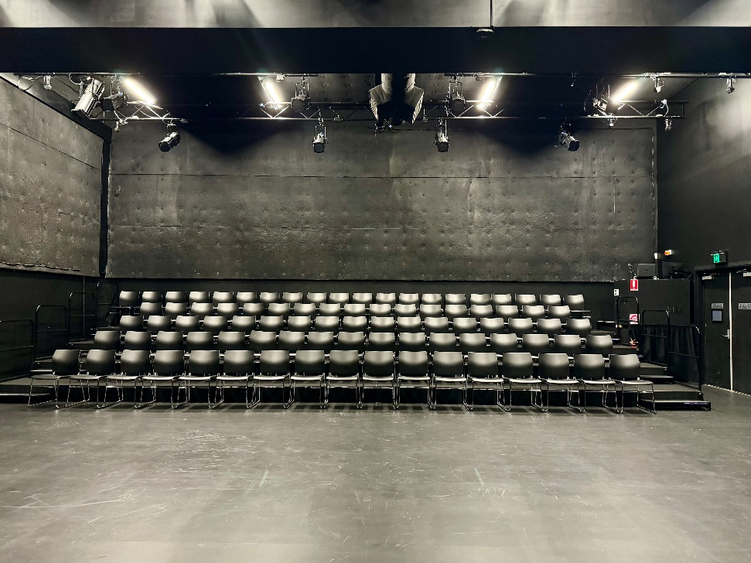

Image: Inside the Diane Cilento Studio, which seats approximately 88 people.

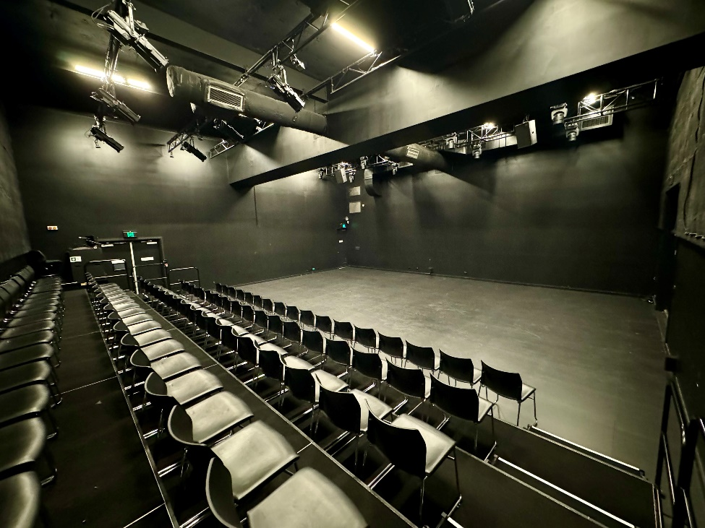

Image: Inside the Studio, looking towards the stage.

The Bille Brown Theatre
The Bille Brown Theatre has two entrances:

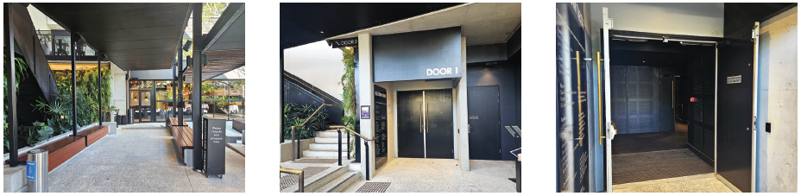

Images: Door 1 is located in the Courtyard, at the end of the ramp and to the left.

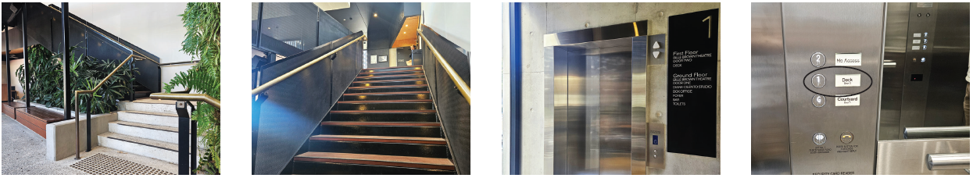

Images: Door 2 is located on the Deck (mezzanine level) and can be accessed by either the staircase in the Courtyard or the lift next to the Box Office.

When the doors open, ushers will check my tickets and guide me to my seat.

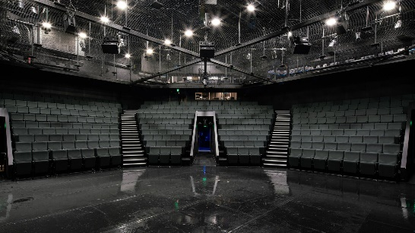

Image: Inside the Bille Brown Theatre, which seats approx. 350 people.

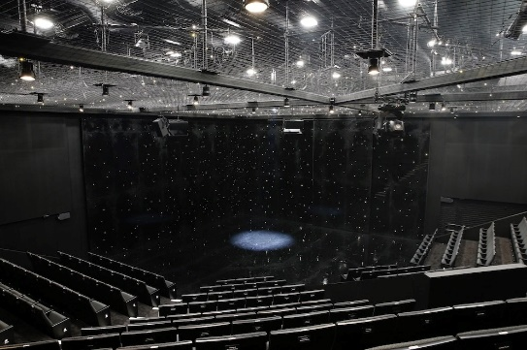

Image: Inside the Bille Brown Theatre, looking towards the stage.

Considerations
- Undercover Artist Festival will not play music in the Foyer or Bar to reduce ambient sounds and sensory overload.

- There will not be any PA announcements. There will be alert chimes at a reduced volume to let me know that theatre doors are opening or closing soon.

- No performances include strobe lighting. Some performances may have sound cues or music - more information is available in the Program: https://undercoverartistfest.com/2025-festival-program/

- Anyone attending Undercover Artist Festival is welcome to bring sensory supports such as tinted glasses, ear plugs, earmuffs and quiet fidgets.

- The Quiet Space is available before, during and after all performances in the Undercover Artist Festival program, where I can stay as long as I need.

Neet to Contact Us?
The Undercover Artist team is incredibly friendly and would love to help answer any questions I may have. I’m welcome to reach out in the following ways:

Website: www.undercoverartistfest.com
Email: undercoverartist@cpl.org.au

